A Tutorial on How to Deploy Your Java EE Cloud Software Application to Run on an Amazon AWS Server

Andres Pico

Graduate Student

Department of Computer Science

Virginia Tech

Blacksburg, Virginia

March 20, 2018

Edited by Dr. Balci on March 21, 2018

**TABLE OF CONTENTS**

DEFINITIONS OF ACRONYMS 3

PURPOSE 4

STEP 1: Create a Virtual Private Server Using AWS 5

1.1 Create an AWS Account 5

1.2 Select and Launch EC2 Instance 7

STEP 2: Set Up a Minimal CentOS Operating System 12

2.1 Update Your System 12

2.2 Install the Links Web Browser 12

2.3 Install wget 12

2.4 Install the GNU Compiler Collection (GCC) 12

2.5 Install HTTP Server 12

2.6 Install PHP 12

2.7 Install nano 12

2.8 Install zip and unzip 12

2.9 Change Passwords 12

2.10 Create a New User 13

STEP 3: VNC Server Installation – Accessing Your VPS Using a GUI for CentOS 15

3.1 Install Desktop for CentOS 15

3.2 Install Firefox Web Browser 15

3.3 Install and Configure VNC Server 15

3.4 Accessing Virtual Private Server through a VNC Client 20

STEP 4: Install GlassFish Application Server 23

4.1 Install Java 23

4.2 Install and Configure GlassFish 25

4.3 Access the GlassFish Administrator Console 28

STEP 5: Install MySQL RDBMS 30

5.1 Install MySQL Server 30

5.2 Start/Stop MySQL Server 30

5.3 Run mysql_secure_installation 30

5.4 Set MySQL Server to Start on Reboot 31

5.5 Access MySQL through the Terminal 31

5.6 Creating Users in Your MySQL Database 32

5.7 Create and View Database Information 32

5.8 Grant All Privileges of a Database to a User 32

5.9 Show All Privileges of a User 33

5.10 Setting up a Database for Your Cloud Software Application 33

STEP 6: Configure GlassFish with MySQL 37

6.1 Download MySQL Connector/J for GlassFish 37

6.2 Create a New Connection Pool on GlassFish 38

6.3 Create New JDBC Resource on GlassFish 42

STEP 7: Allocate an Elastic (Static) IP Address for Your Amazon VPS and Set up Your Domain 44

7.1 Allocate New Elastic IP Address 44

7.2 Obtain and Use a Domain Name for Your VPS 48

STEP 8: Copying WAR Files to Your VPS 50

8.1 Copy Your WAR File Using SCP 50

STEP 9: Deploy Your Cloud Software Application Using GlassFish 51

9.1 Open EC2 Instance Ports 51

9.2 Open VPS Firewall Ports 53

9.3 Deploy Your Cloud Software Application 54

9.4 Hide Port 8080 57

REFERENCES 62

DEFINITIONS OF ACRONYMS

AWS Amazon Web Services

CentOS **C**ommunity **ent**erprise **O**perating **S**ystem

EC2 Amazon Elastic Compute Cloud

GlassFish Java EE Application Server

GUI Graphical User Interface

HTTP HyperText Transfer Protocol

HTTPS HyperText Transfer Protocol Secure

HVM Hardware Virtual Machine

IP Internet Protocol

JAR Java ARchive

JDBC Java DataBase Connectivity

JDK Java Development Kit

JNDI Java Naming and Directory Interface

MySQL My Structured Query Language RDBMS

RDBMS Relational DataBase Management System

SDK Software Development Kit

SQL Structured Query Language

SSD Solid State Drive

SSH Secure SHell

VNC Virtual Network Computing

VPS Virtual Private Server

WAR Web application ARchive

PURPOSE

The purpose of this tutorial is to instruct the reader on how to deploy a Java EE cloud software application to run on an Amazon AWS server.

This tutorial covers the following learning objectives:

* How to create an Amazon EC2 instance or Virtual Private Server (VPS).
* How to set up a minimal version of the CentOS operating system with the tools needed to complete this tutorial.
* How to set up Virtual Network Computing (VNC) in the virtual private server to access its graphical user interface. VNC is a graphical desktop sharing system to remotely control another computer.
* How to install and configure GlassFish Application Server.
* How to copy Java EE application's WAR files from your local computer to your VPS.
* How to allocate an elastic (static) IP address to your VPS.
* How to link your IP address to your domain.
* How to install and configure MySQL database server in your VPS server.
* How to configure GlassFish with MySQL.
* How to successfully deploy your cloud software application using GlassFish console.

# STEP 1: Create a Virtual Private Server Using AWS

We start the tutorial by teaching you how to properly create a Virtual Private Server (VPS) or Amazon Elastic Compute Cloud (EC2) instance using Amazon Web Services (AWS).

## Create an AWS Account

Open your web browser and access Amazon web services: <https://aws.amazon.com/>

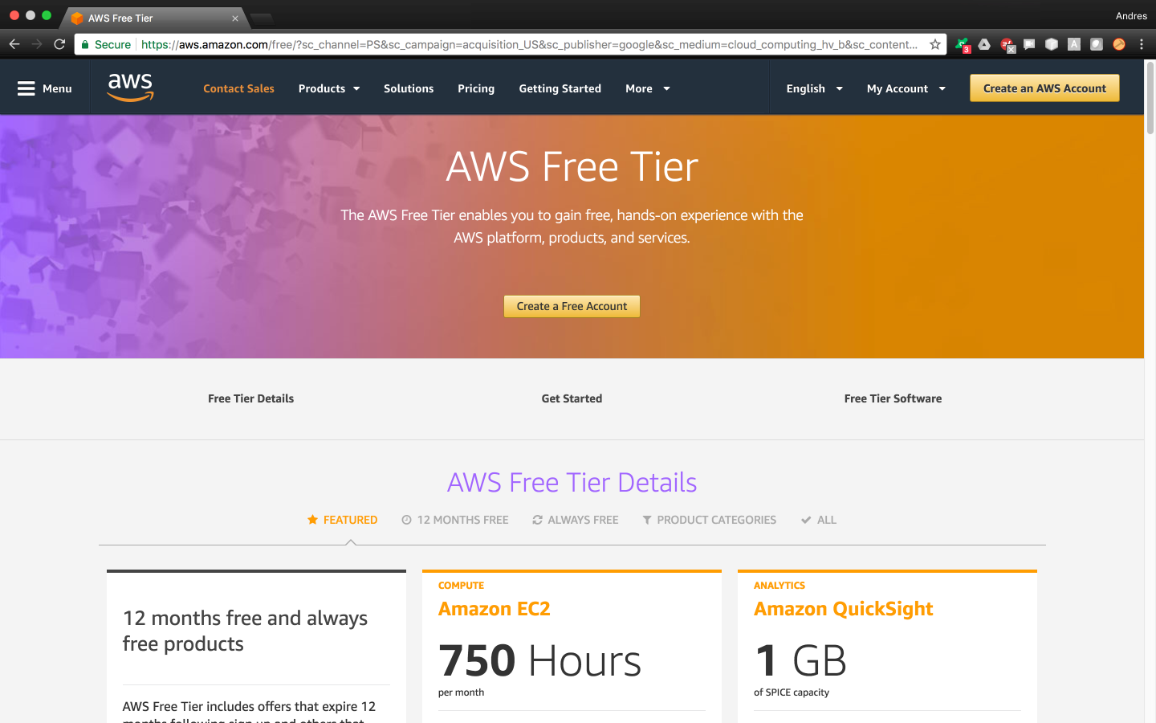

Proceed to create an account:  
  
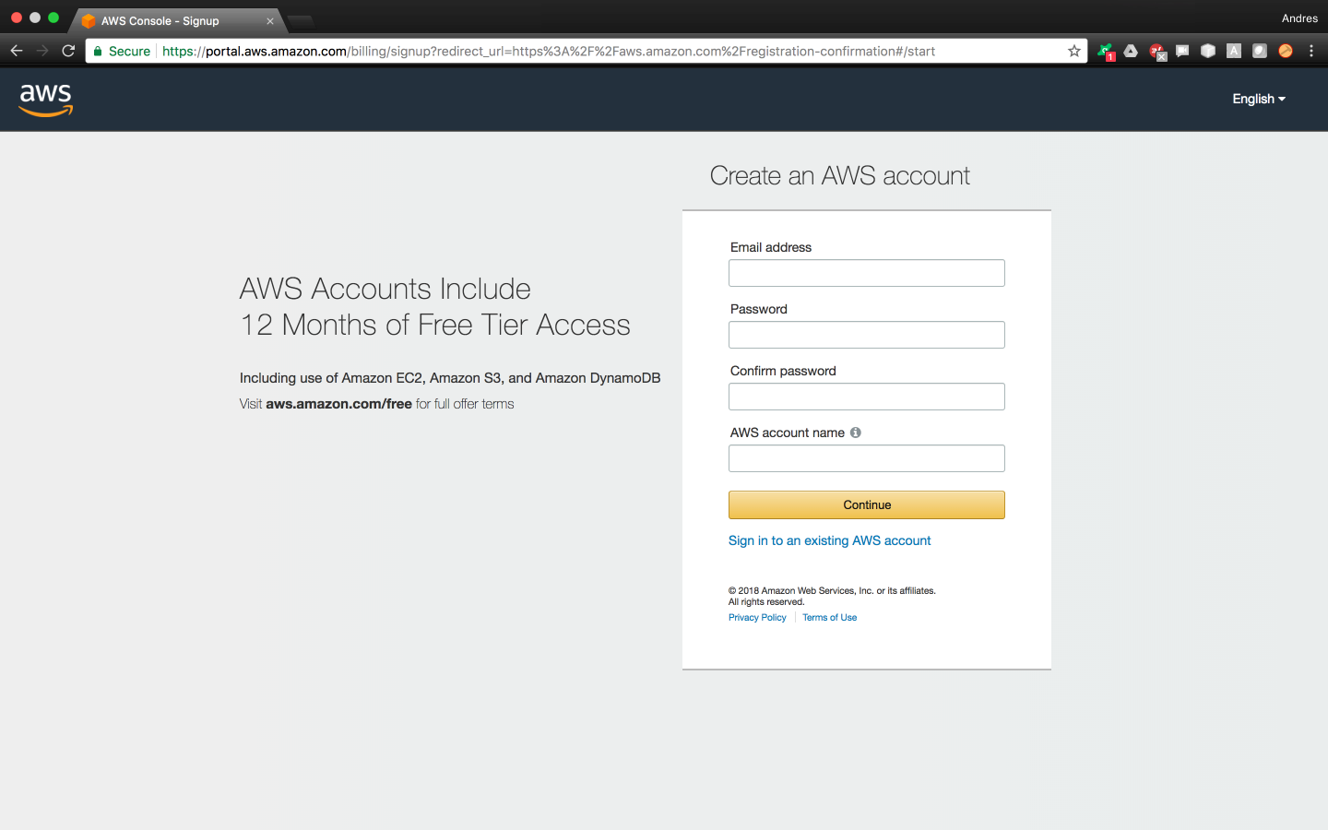

Select the basic plan (free)



## Select and Launch EC2 Instance

Once the account has been created, hover on top of the ‘Services’ tab and select ‘EC2’



Doing this will take you to the EC2 Dashboard where you will click on the blue button named ‘**Launch Instance’**



In the next screen, select ‘AWS Marketplace’ from the menu located on the left. Search for CentOS 6 (x86_64) with updates Hardware Virtual Machine (HVM) as shown below. (Note that as March 2018, the CentOS 7 offered by AWS Marketplace is unreliable. Therefore, we selected version 6.)

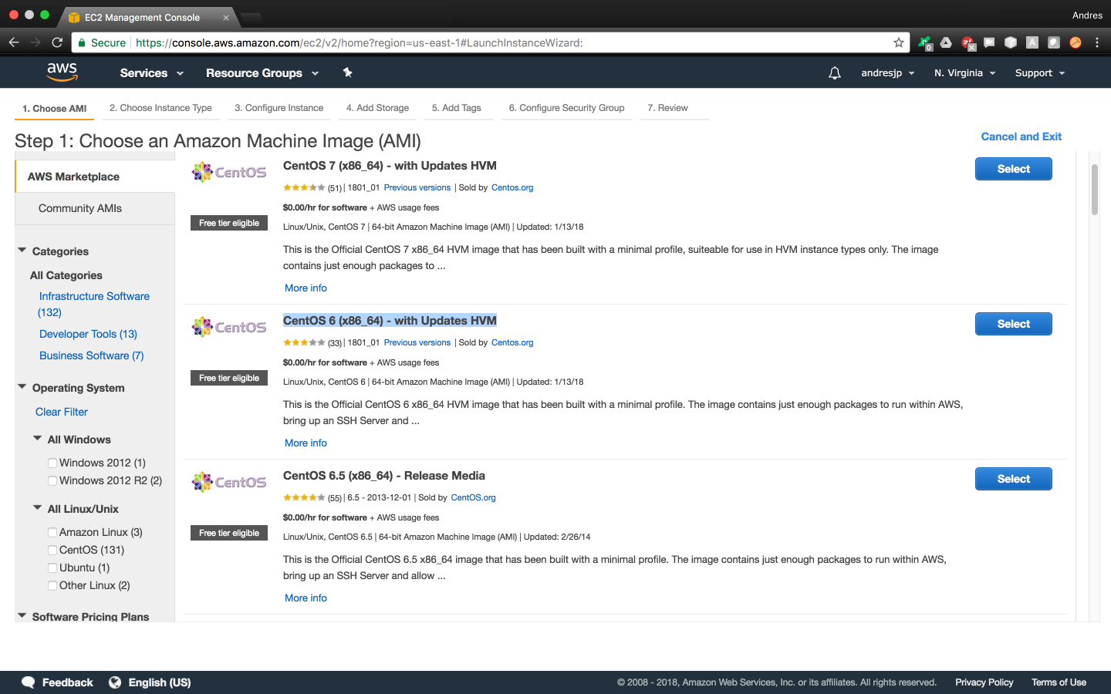

After selecting your desired Amazon machine image, you’ll choose your instance type.



Don’t forget to adjust the memory size you need, and to select a General Purpose Solid State Drive (SSD) as your type of storage for increased performance.



You’ll also need a public/private key pair to access your VPS through SSH. We’ll name ours ‘**masterJediKeyPair**’ and proceed to download it.



And that’s it! You’ve successfully launched your EC2 instance!

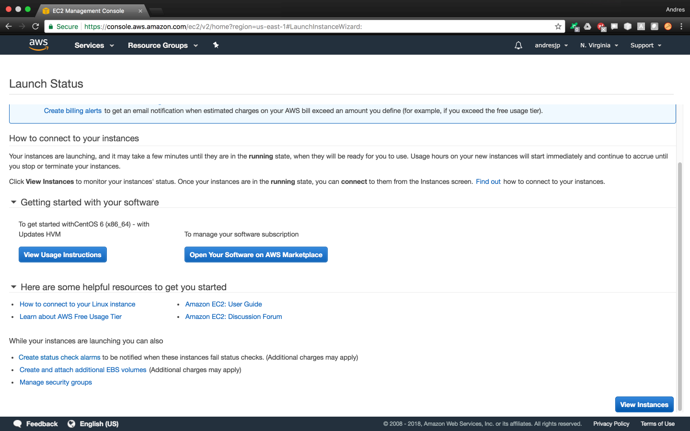

Now click on the ‘View Instances’ blue button to access your EC2 console where you’ll be able to manage and find all the information regarding your instances.

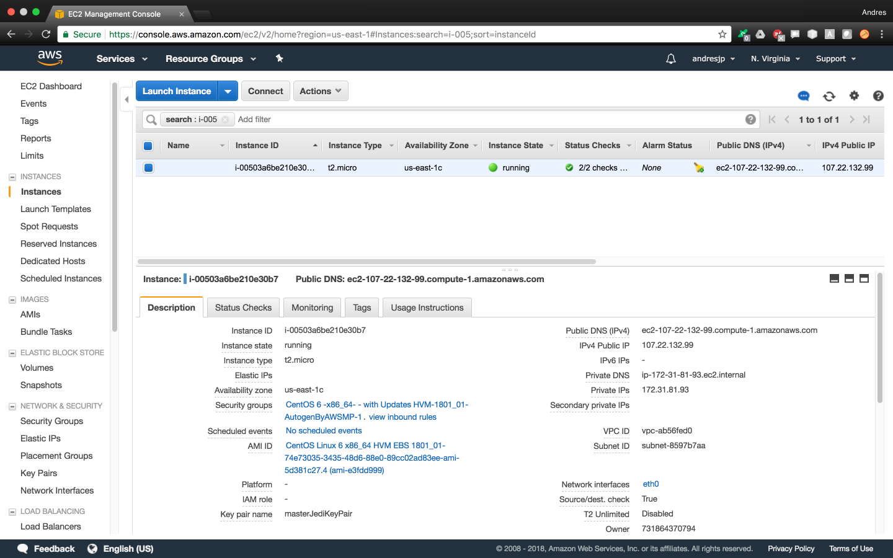

Before accessing your VPS however, you’ll need to move the ‘masterJediKeyPair.pem’ file you just downloaded into the “~/.ssh/” directory on your local machine. Then you’ll modify the file’s privileges to protect it against accidental overwriting by running the chmod command below:

user$ sudo mv masterJediKeyPair.pem ~/.ssh/

user$ chmod 400 ~/.ssh/masterJediKeyPair.pem

Now you’ll be able to SSH into the ‘centos’ default user in your VPS by running the script below. (Replace the IP address in the script with yours)

user$ ssh -i "~/.ssh/masterJediKeyPair.pem" centos@107.22.132.99

The authenticity of host '107.22.132.99 (107.22.132.99)' can't be established.

RSA key fingerprint is SHA256:/+O6KCLXU2mk5sUlQQevcwDoYX9UntppqxGcewIZ+30.

Are you sure you want to continue connecting (yes/no)? yes

Warning: Permanently added '107.22.132.99' (RSA) to the list of known hosts.

[centos@ip-172-31-81-93 ~]$ ls

You’re in! ☺

# STEP 2: Set Up a Minimal CentOS Operating System

Notice that you just created a virtual private server with a minimal CentOS 6, which means that your server only has the most basic tools and commands provided by linux. But don’t worry, we’ll walk you through the steps to download everything you need for this tutorial and more. The commands below will be executed from the default ‘centos’ user account in your VPS which has root privileges.

## Update Your System

Update your system with the latest versions of your packages

centos$ sudo yum update kernel

centos$ sudo yum update && yum upgrade

## Install the Links Web Browser

This web browser will allow you to navigate the web though the terminal

centos$ sudo yum install links

## Install wget

Tool to retrieve content from web servers that you’ll use to download programs into your VPS

centos$ sudo yum install wget

## Install the GNU Compiler Collection (GCC)

centos$ sudo yum install gcc

## Install HTTP Server

centos$ sudo yum install httpd

## Install PHP

centos$ sudo yum install php

## Install nano

Nano is a free and lightweight text editor used in linux environments. You are free to use other text editors you like, but we recommend you to use ‘nano’ if you are a beginner or have low experience in linux environments

centos$ sudo yum install nano

## Install zip and unzip

Tools zip & unzip will allow you to compress and decompress zipped packages later on

sudo yum install zip unzip -y

## Change Passwords

We can use the following password ‘masterJedi’ for the purposes of the tutorial.

But please keep in mind that this is a highly unsecure password for continued use

centos$ sudo passwd root

New password:

Retype new password:

passwd: all authentication tokens updated successfully.

Now it’s time to change the password for the default ‘centos’ user account. Note that if you try to change the password directly from ‘centos’ account, it will ask for a password which we don’t have. Instead, we’ll switch users to ‘root’ and change the ‘centos’ user password from there.

centos$ su – root

Password:

root$ sudo passwd centos

New password:

Retype new password:

passwd: all authentication tokens updated successfully.

## Create a New User

We’ll now create a new user ‘padawan’ which we’ll use for everything from now on. For the purposes of this tutorial we’ll use the password ‘apprenticeJedi’.

root$ adduser padawan

root$ passwd padawan

Changing password for user padawan.

New password:

Retype new password:

passwd: all authentication tokens updated successfully.

Now we will grant our ‘padawan’ user with root privileges by adding it to the wheel group. However, users that belong to the wheel group are not originally granted root privileges so we’ll have to access the ‘sudoers’ file.

root$ usermod -aG wheel padawan

root$ nano /etc/sudoers

Once inside, we’ll proceed to uncomment the highlighted line below as shown in the picture 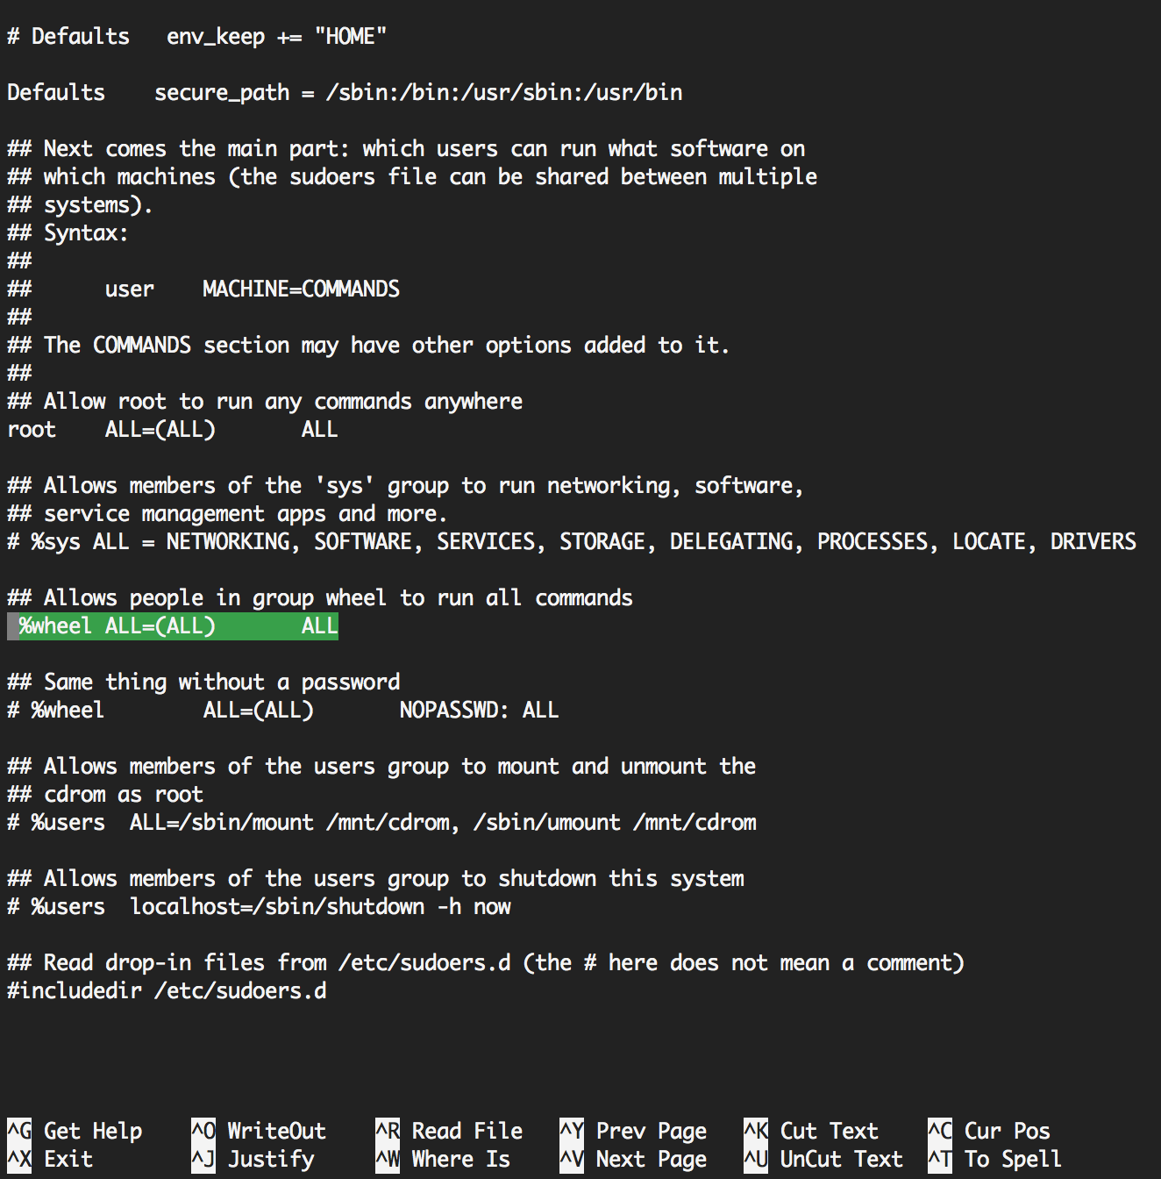

Your user will now have root privileges after saving the changes. As a final step, we’ll test if we were successful in granting root privileges to our user. If successful, we shall see the following:

root$ su - padawan

padawan$ sudo ls -la /root

We trust you have received the usual lecture from the local System

Administrator. It usually boils down to these three things:

    #1) Respect the privacy of others.

    #2) Think before you type.

    #3) With great power comes great responsibility.

[sudo] password for padawan:

total 48

dr-xr-x---.  3 root root  4096 Mar 18 15:58 .

dr-xr-xr-x. 24 root root  4096 Mar 18 15:58 ..

-rw-r--r--.  1 root root    18 May 20  2009 .bash_logout

-rw-r--r--.  1 root root   176 May 20  2009 .bash_profile

-rw-r--r--.  1 root root   176 Sep 23  2004 .bashrc

-rw-r--r--.  1 root root   100 Sep 23  2004 .cshrc

-rw-r--r--.  1 root root 10312 Jan  8 16:16 install.log

-rw-r--r--.  1 root root  3317 Jan  8 16:15 install.log.syslog

drwx------.  2 root root  4096 Mar 18 15:58 .ssh

-rw-r--r--.  1 root root   129 Dec  3  2004 .tcshrc

FYI, you can also grant root privileges uniquely to your desired user rather than the whole wheel group in the sudoers file.

# STEP 3: VNC Server Installation – Accessing Your VPS Using a GUI for CentOS

Up until now we can only operate our virtual private server though the terminal by connecting to it using SSH. However, we are visual creatures and in order to make our job easier, we’ll set up a CentOS desktop in our VPS which we’ll access using Virtual Networking Computing (VNC). Please note that connections to VNC are unencrypted, so you might want to use your VNC client in a secure network to avoid eavesdropping.

## Install Desktop for CentOS

root$ yum groupinstall Desktop

## Install Firefox Web Browser

Firefox will let you navigate the web in a more user-friendly environment than ‘links’.

root$ yum install gnome-core xfce4 firefox

## Install and Configure VNC Server

Installing VNC server will allow you to access your VPS desktop using a VNC client remotely. Make sure to configure the vnc server to run on startup by executing the chkconfig command.

root$ yum install tigervnc-server

root$ yum install vnc

root$ chkconfig vncserver on

Now let’s set a password to access VNC remotely. For the purposes of this tutorial we’ll use the same password we used for the user account: ‘apprenticeJedi’.

root$ su – padawan

padawan$ vncpasswd

Password:

Verify:

The next step is to configure the ‘vncservers’ file to allow connections to our user account through the default port 5901.

padawan$ sudo nano /etc/sysconfig/vncservers

Make the following changes to the file:

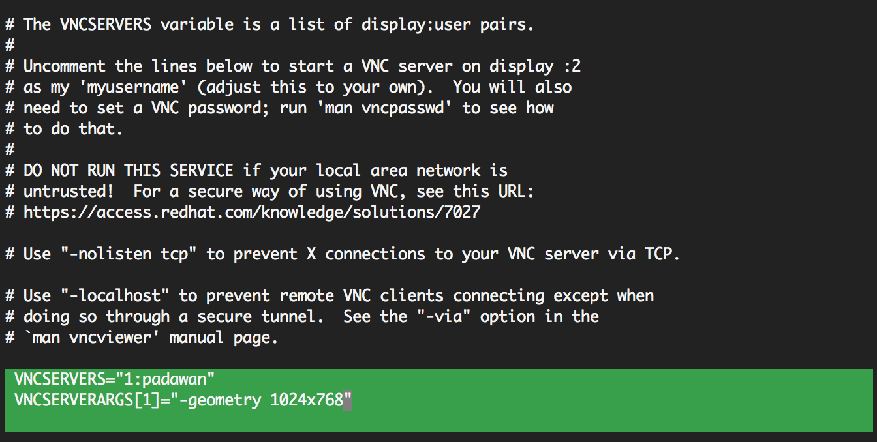

Now we have to make sure that we allow connections to the default VNC ports through the firewall. Otherwise, we won’t be able to establish a connection.

padawan$ sudo iptables -I INPUT 5 -m state --state NEW -m tcp -p tcp -m multiport --dports 5901:5903,6001:6003 -j ACCEPT

padawan$ sudo service iptables save

iptables: Saving firewall rules to /etc/sysconfig/iptables:[  OK  ]

padawan$ sudo service iptables restart

iptables: Setting chains to policy ACCEPT: filter          [  OK  ]

iptables: Flushing firewall rules:                         [  OK  ]

iptables: Unloading modules:                               [  OK  ]

iptables: Applying firewall rules:                         [  OK  ]

Restart the VNC server for changes to take effect.

padawan$ sudo service vncserver restart

Shutting down VNC server:                                  [  OK  ]

Starting VNC server: 1:padawan xauth:  file /home/padawan/.Xauthority does not exist

New 'ip-172-31-81-93:1 (padawan)' desktop is ip-172-31-81-93:1

Creating default startup script /home/padawan/.vnc/xstartup

Starting applications specified in /home/padawan/.vnc/xstartup

Log file is /home/padawan/.vnc/ip-172-31-81-93:1.log

                                                           [  OK  ]

Proceed to kill the vncserver process in order to modify the configuration of our ‘xstartup’ file.

padawan$ vncserver -kill :1

Killing Xvnc process ID 16134

padawan$ nano /home/padawan/.vnc/xstartup

Now make the following changes as highlighted below.

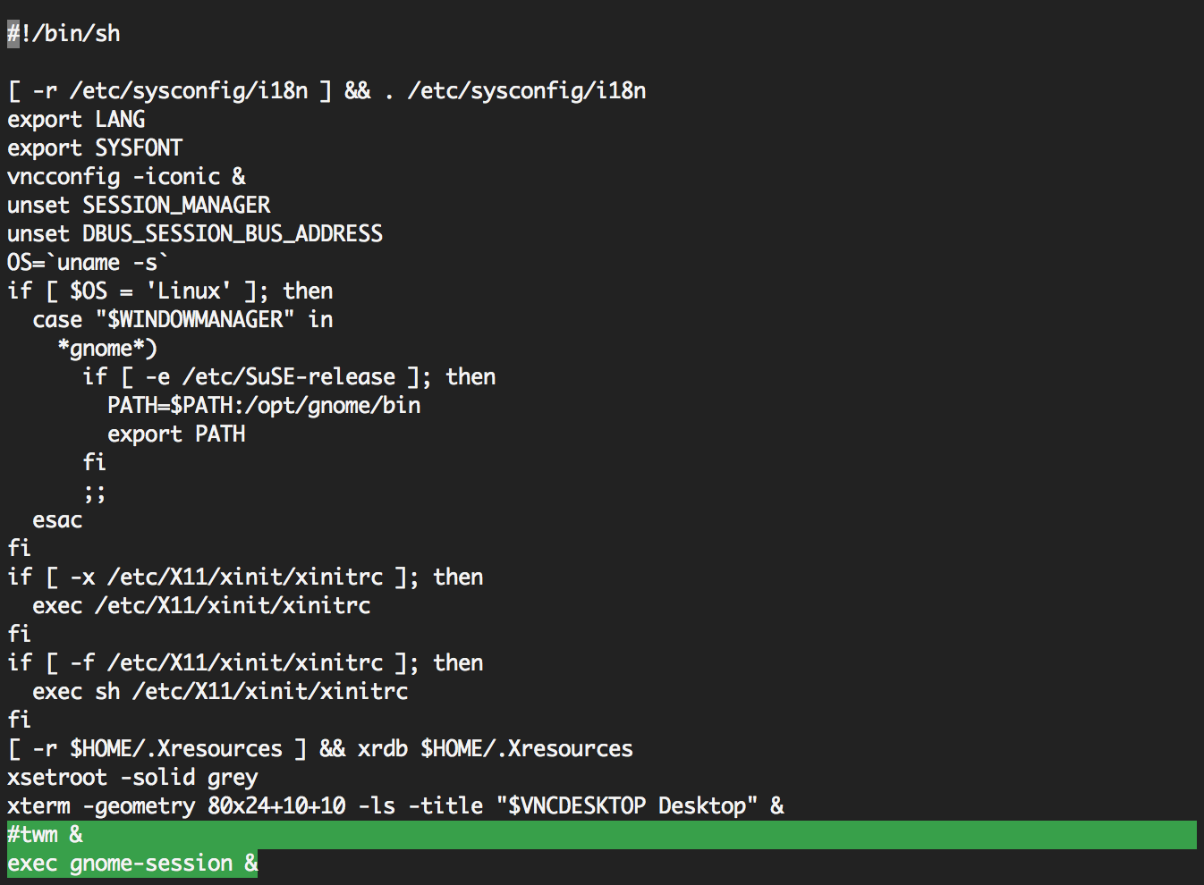

Normally, you’d be able to access the CentOS desktop through a vnc-client by now. However, since we are using Amazon web services, we need to open the VNC ports through our EC2 console as well. To do this, we’ll access our instance’s security group, and then we’ll proceed to specify the ports we want to use.

Open your EC2 Console, locate your instance, and scroll all the way to the right to find your instance’s security groups. Then click on it.

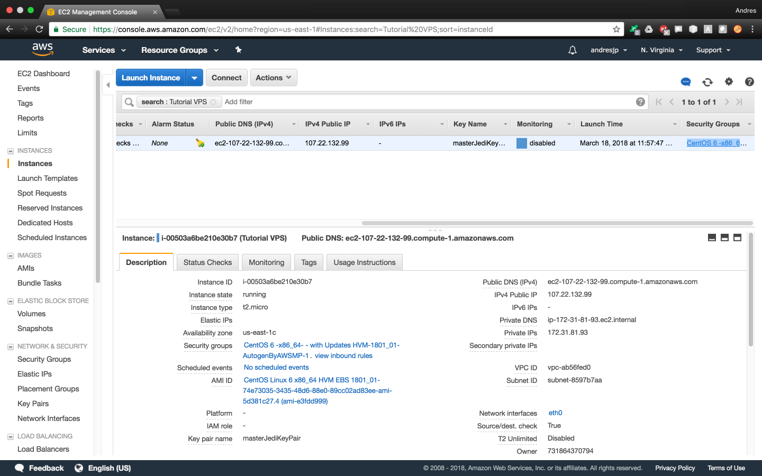

Now that you’ve accessed your instance’s security groups, you want to select the ‘Inbound’ tab and then click on ‘Edit’.

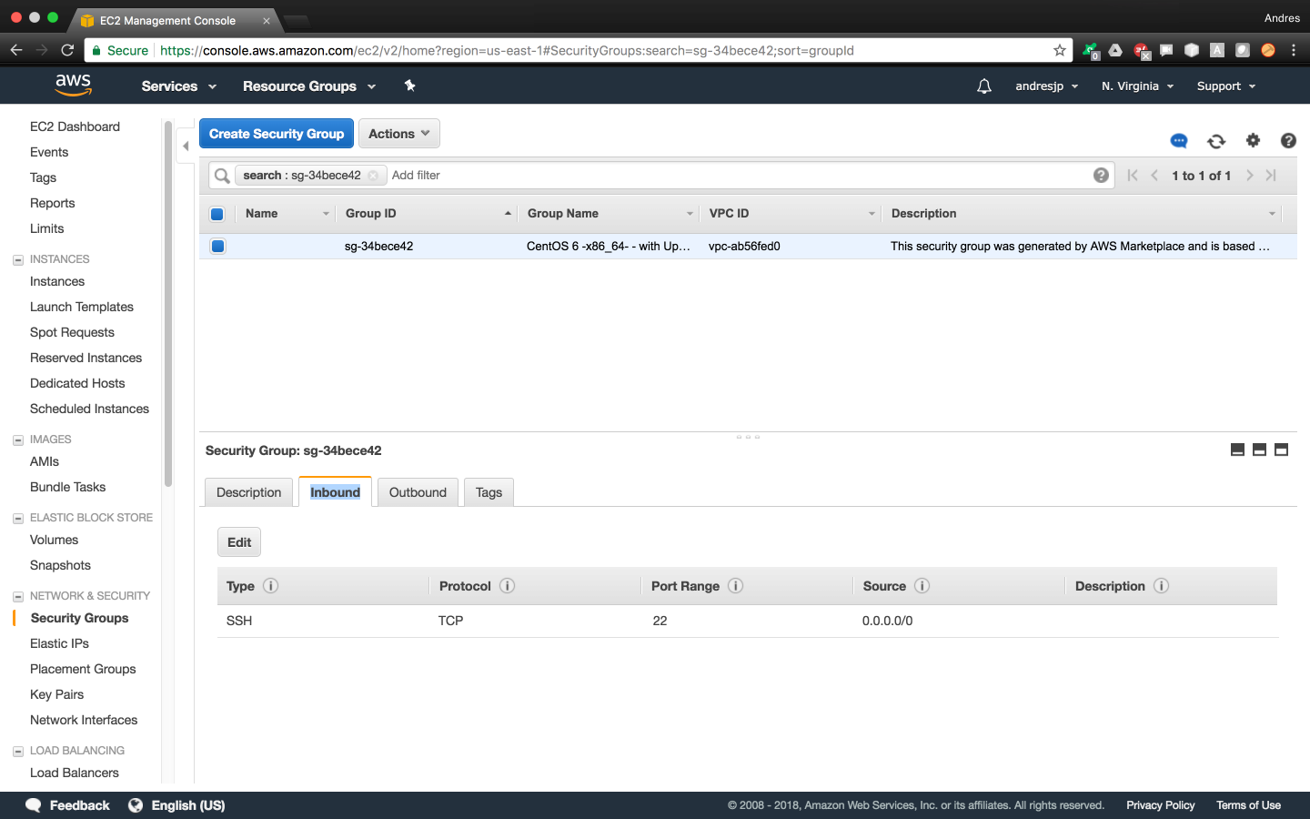

At this point, we’ll add a rule to allow incoming connections to the default VNC ports.

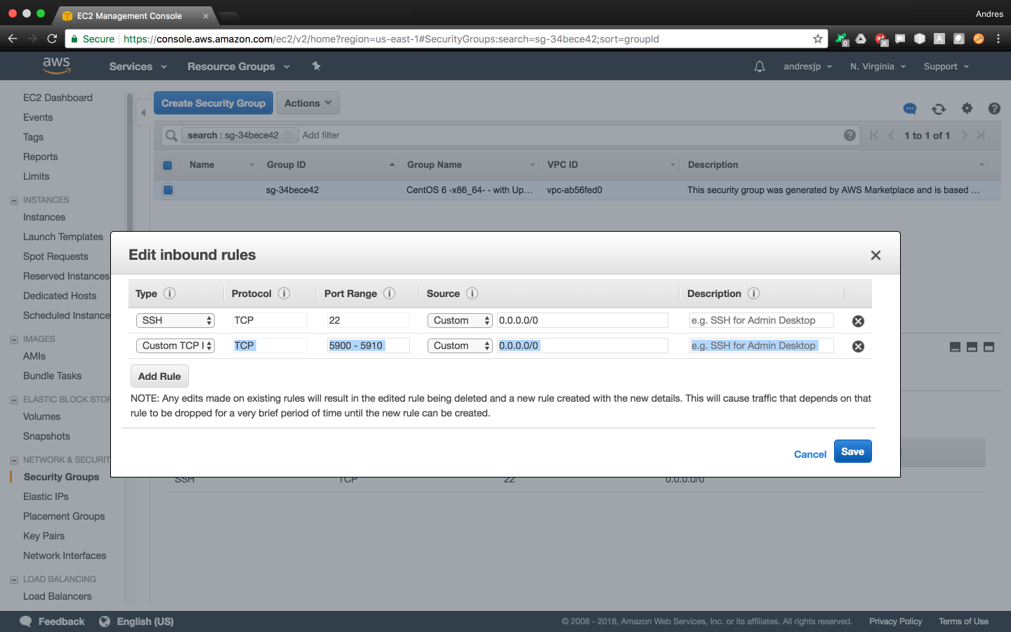

Make sure you added the rule correctly by verifying that your changes show up after saving.

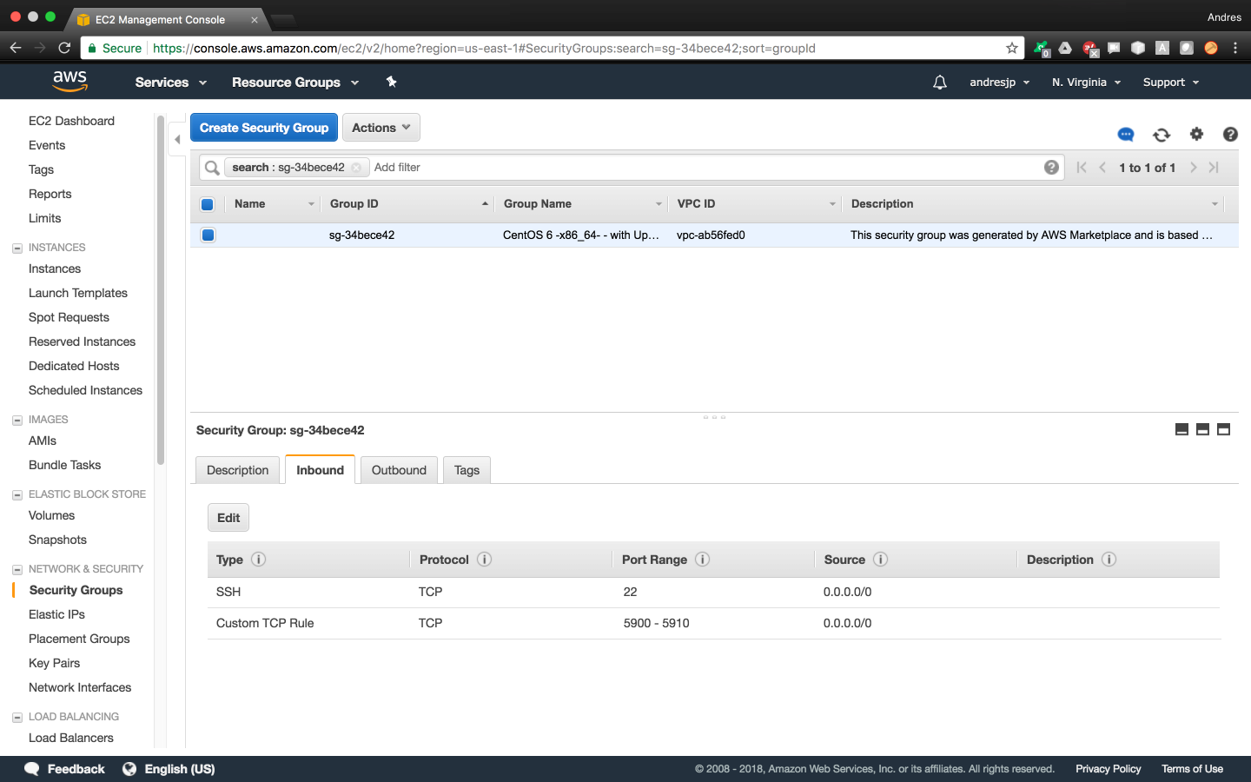

Finally, reboot your instance for changes to take effect.

## Accessing Virtual Private Server through a VNC Client

Although there are many vnc-clients available out there, we’ll use a cross-platform vnc-client called ‘RealVNC’ in this tutorial. Visit: <https://www.realvnc.com/en/connect/download/vnc/>

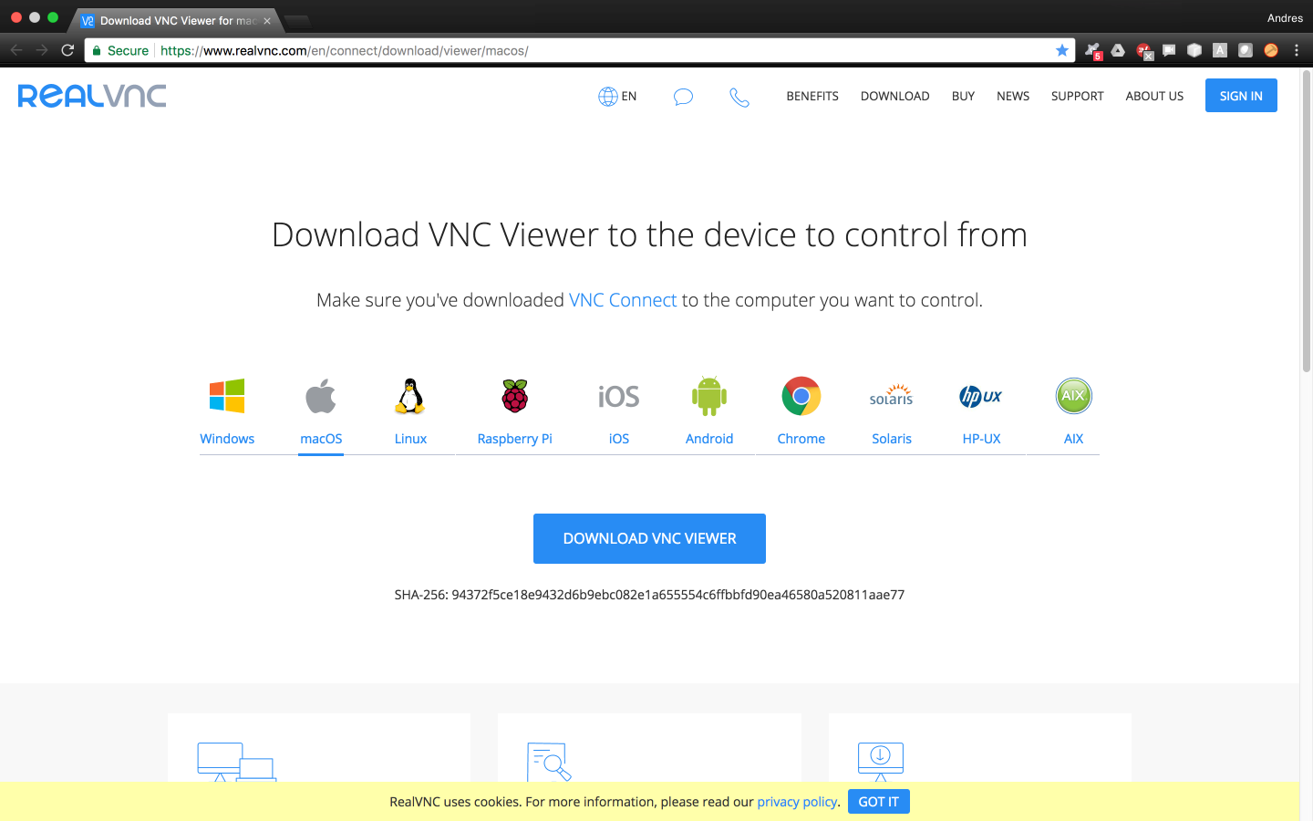

Once downloaded, open the vnc-client and connect to your EC2 instance. Make sure to access your instance by using its public IP address, and use the vnc password we chose in 3.3.

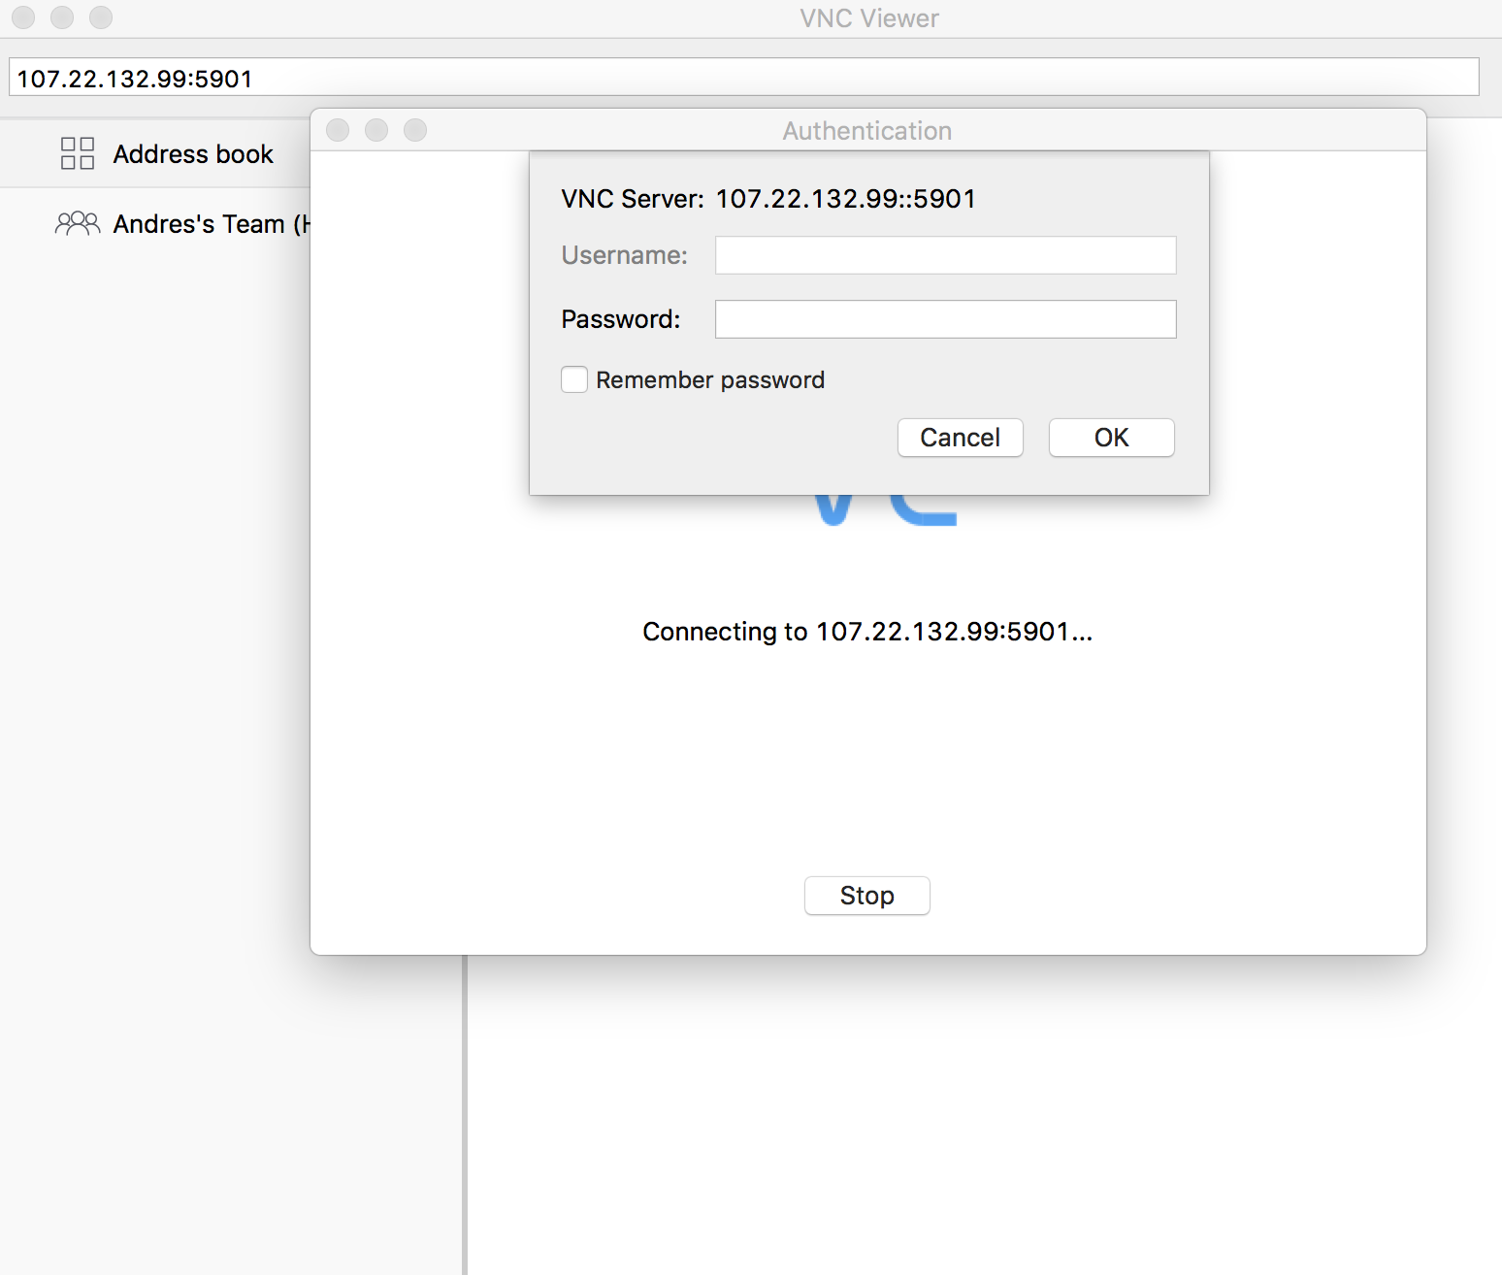

After successful login, you will see the following screens.

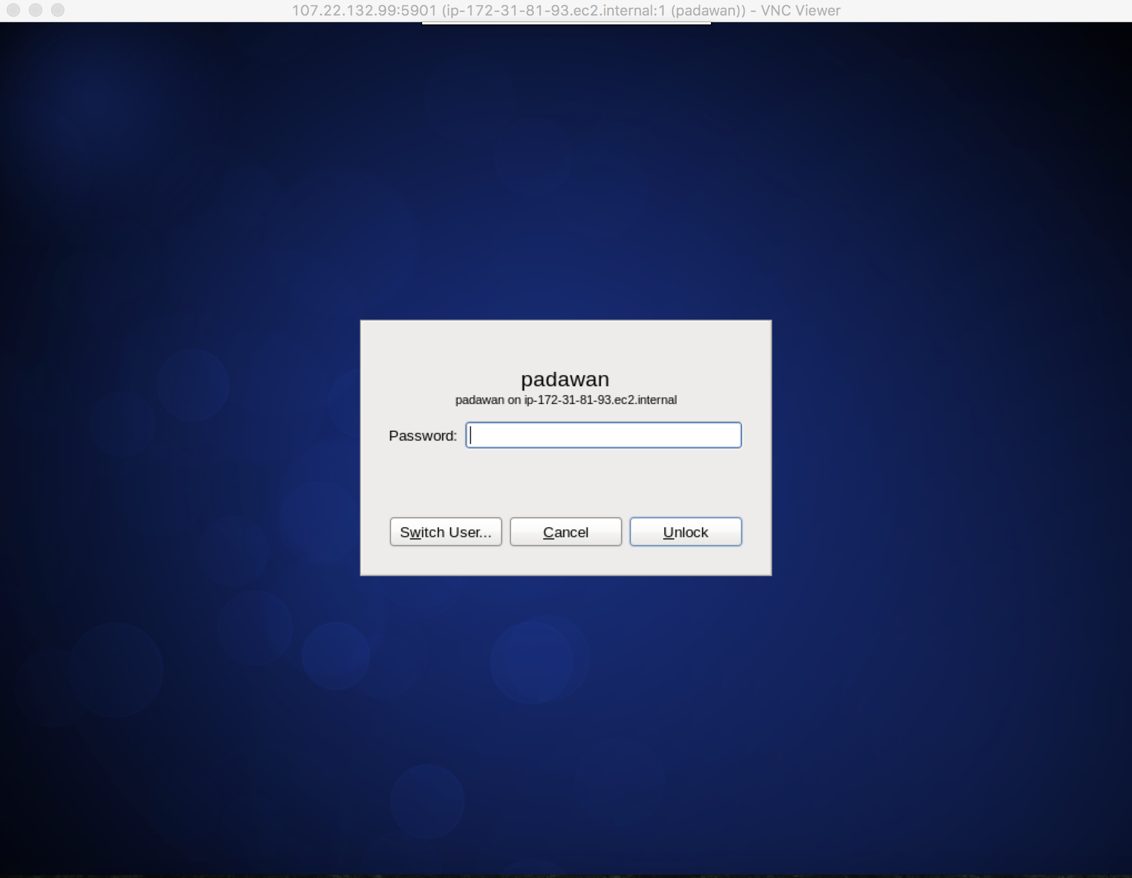

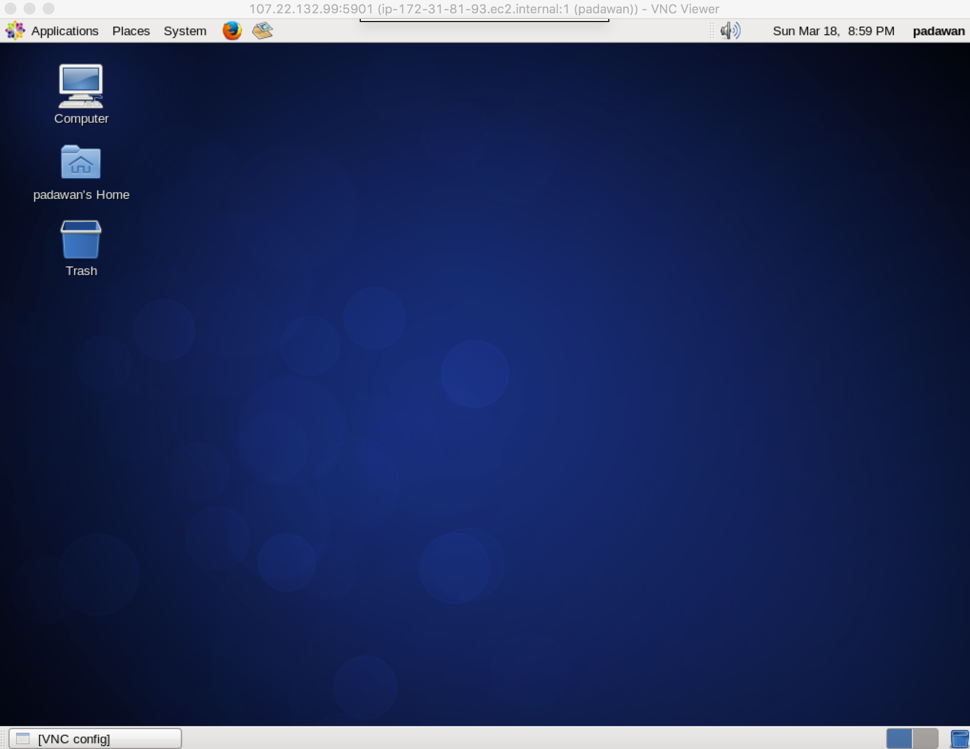

# STEP 4: Install GlassFish Application Server

Now that we have finished setting up our VPS, we will install GlassFish to deploy our cloud software applications.

## Install Java

Access the following link from Firefox in your VPS: <http://www.oracle.com/technetwork/java/javase/downloads/index.html>

Proceed to download the Java 8 JDK.

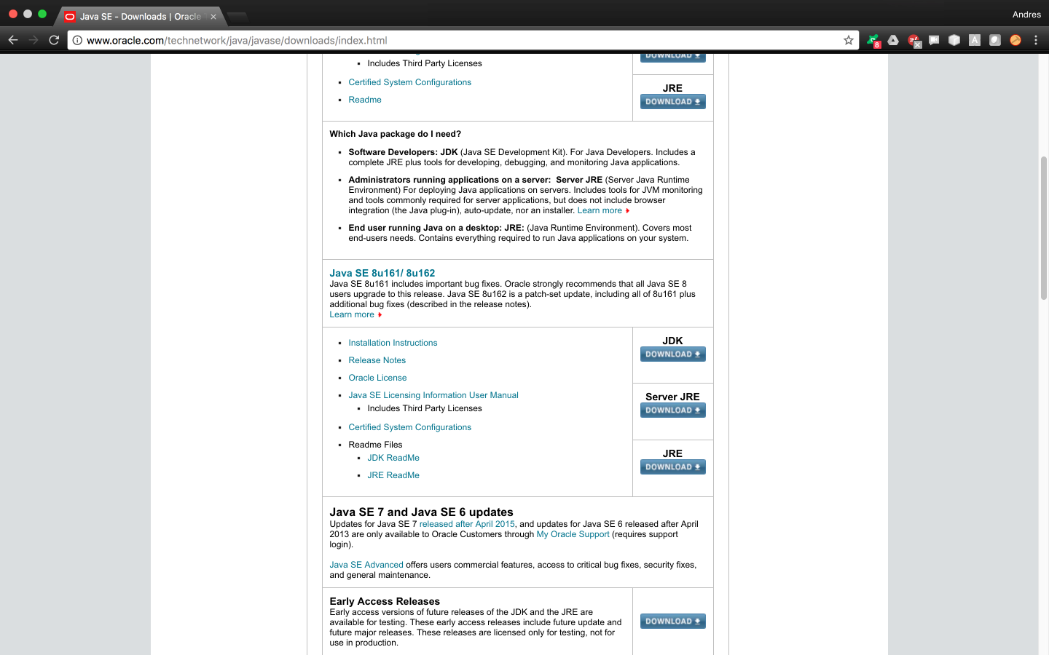

Accept the license agreement, and choose the highlighted ‘Linux x64.tar.gz’ compressed file. This file will be downloaded in your ‘Downloads’ folder.

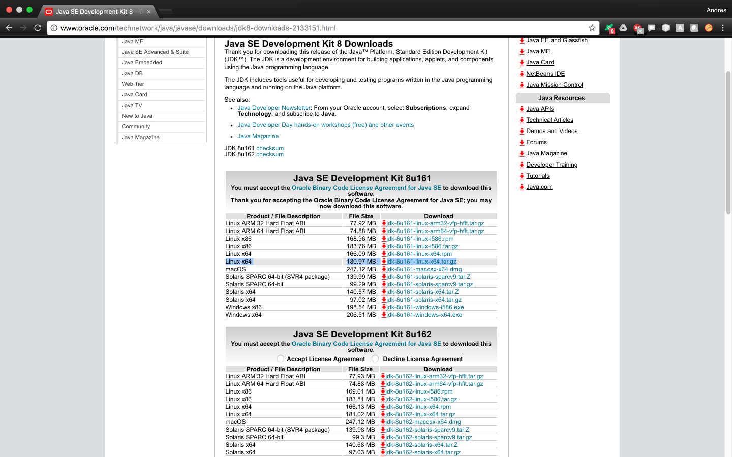

Once downloaded, we’ll create the directory */usr/java* where we will store the Java SDK. Then we’ll change directory into it “*cd /usr/java*”, and we’ll proceed to decompress the tar.gz Java SDK. Make sure the SDK was stored in the right directory after it is decompressed.

padawan$ sudo mkdir /usr/java

padawan$ cd /usr/java

padawan$ sudo tar –xvf ~/Downloads/jdk-8u161-linux-x64.tar.gz

padawan$ ls /usr/java

jdk1.8.0_161

Now we’ll set the location of JAVA_HOME, and add it to our PATH variable. Please note that you have to follow the steps below for both our *root* and *padawan* users.

padawan$ nano ~/.bash_profile

root$ nano ~/.bash_profile

Add the following changes to both files.

# .bash_profile

# Get the aliases and functions

if [ -f ~/.bashrc ]; then

. ~/.bashrc

fi

# User specific environment and startup programs

JAVA_HOME=/usr/java/jdk1.8.0_161

export JAVA_HOME

PATH=$JAVA_HOME/bin:$PATH:$HOME/bin

export PATH

Finally, reboot the server and make sure that JAVA_HOME is set correctly

root$ echo $JAVA_HOME

/usr/java/jdk1.8.0_161

root$ su - padawan

padawan$ echo $JAVA_HOME

/usr/java/jdk1.8.0_161

## Install and Configure GlassFish

Access the following link from Firefox in your VPS: <https://javaee.github.io/glassfish/>

Click on Download and locate ‘glassfish-4.1.2.zip’. Please be wary that GlassFish 4.1.1 contains a bug that won’t allow you to configure MySQL correctly.  
  
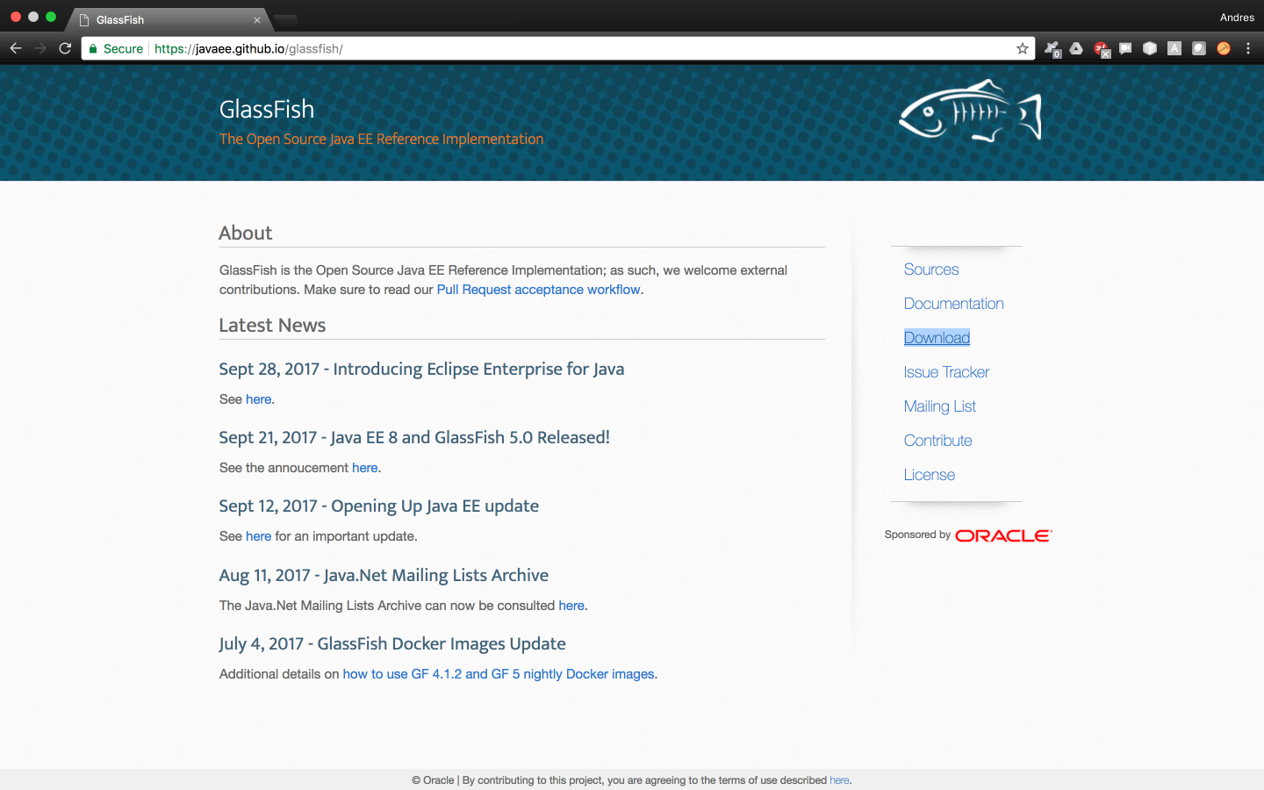  
  
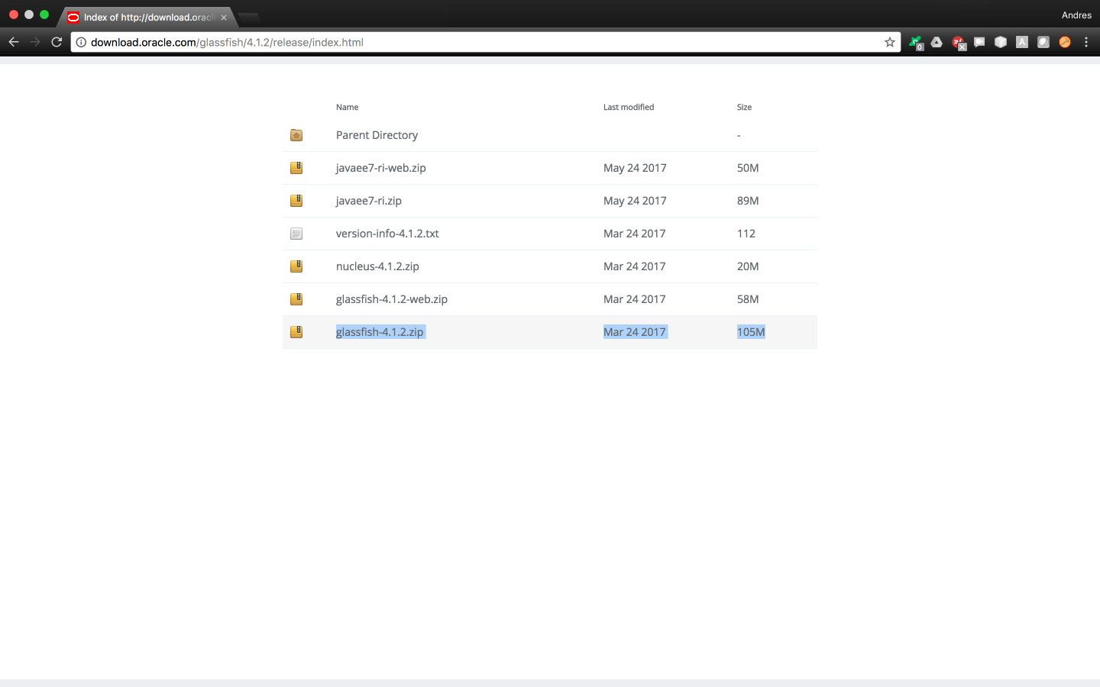

Let’s unzip the glassfish file under the */usr/share* now. If successful, a new folder called ‘*glassfish4*’ will be created.

padawan$ cd /usr/share

padawan$ sudo unzip ~/Downloads/glassfish-4.1.2.zip

padawan$ ls /usr/share/glassfish4/

bin  glassfish  javadb  mq  README.txt

We’ll now change the GlassFish administrator password for obvious security reasons. Please keep in mind that the default admininstrator username is ‘*admin*’. Also note that there’s no default admin password so just press enter when it asks you for it. Finally, we’ll use the password ‘*CSD@gf-1872*’ for the purposes of this tutorial.

padawan$ su – root

root$ /usr/share/glassfish4/bin/asadmin change-admin-password

Enter admin user name [default: admin]>admin

Enter the admin password>

Enter the new admin password>

Enter the new admin password again>

Command change-admin-password executed successfully.

In order to make our lives easier along the way, we’ll create a script for starting, stopping, and restarting GlassFish.

root$ cd /etc/init.d

root$ nano glassfish

An empty file will open, and we’ll insert the script below and then save it.

#!/bin/bash

# description: Glassfish Start Stop Restart

# processname: glassfish

# chkconfig: 234 20 80

JAVA_HOME=/usr/java/jdk1.8.0_161

export JAVA_HOME

PATH=$JAVA_HOME/bin:$PATH

export PATH

GLASSFISH_HOME=/usr/share/glassfish4/glassfish

case $1 in

start)

sh $GLASSFISH_HOME/bin/asadmin start-domain domain1

;;

stop)

sh $GLASSFISH_HOME/bin/asadmin stop-domain domain1

;;

restart)

sh $GLASSFISH_HOME/bin/asadmin stop-domain domain1

sh $GLASSFISH_HOME/bin/asadmin start-domain domain1

;;

esac

exit 0

To make sure our script works correctly, we’ll use chmod to make it executable and proceed to restart the GlassFish server. If successful, you should see something similar to this:

root$ chmod +x /etc/init.d/glassfish

root$ /etc/init.d/glassfish restart

CLI306: Warning - The server located at /usr/share/glassfish4/glassfish/domains/domain1 is not running.

Command stop-domain executed successfully.

Waiting for domain1 to start .......

Successfully started the domain : domain1

domain  Location: /usr/share/glassfish4/glassfish/domains/domain1

Log File: /usr/share/glassfish4/glassfish/domains/domain1/logs/server.log

Admin Port: 4848

Command start-domain executed successfully.

Finally, we’ll set up our glassfish server to start up whenever the server boots up.

root$ chkconfig --add /etc/init.d/glassfish

root$ chkconfig glassfish on

## Access the GlassFish Administrator Console

Now that we have installed and configured GlassFish in our VPS, we’ll access its admin console by opening Firefox and visiting the following url: <http://localhost:4848>

The GlassFish Admin Console Sign-In screen will then appear.

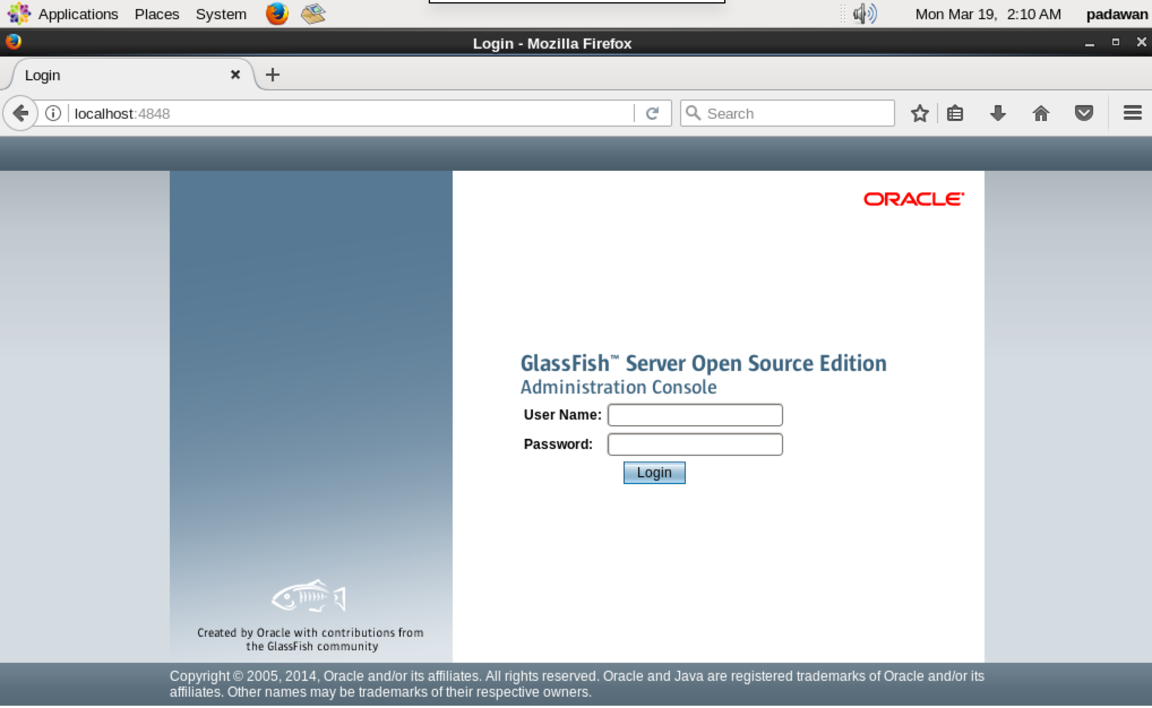

After a successful sign-in, you’ll be redirected to the GlassFish Console Home screen.

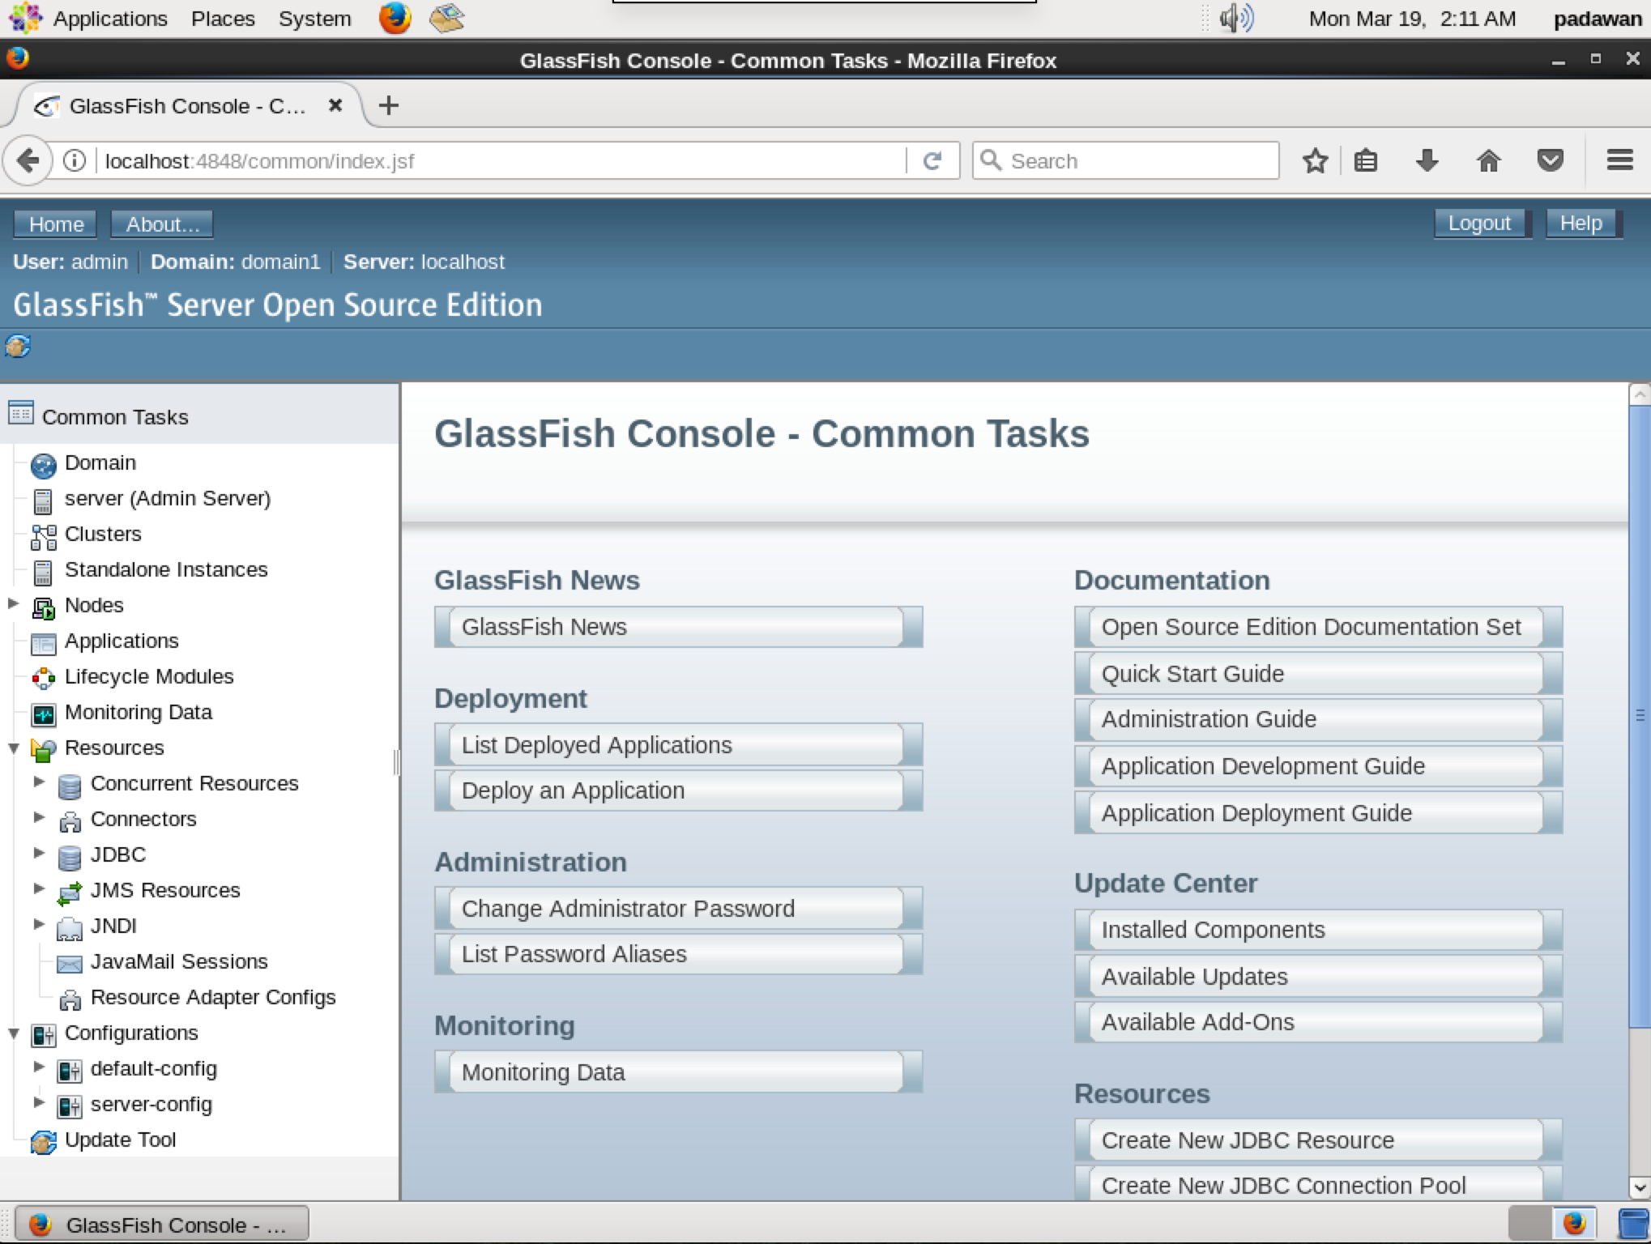

# STEP 5: Install MySQL RDBMS

Even though we are technically able to proceed to step 7, we won’t be able to use MySQL Relational DataBase Management System (RDBMS) in our applications just yet. This section covers how to install and configure MySQL in your CentOS virtual private server.

## Install MySQL Server

root$ sudo yum install mysql-server

## Start/Stop MySQL Server

root$ sudo /sbin/service mysqld start

root$ sudo /sbin/service mysqld stop

## Run mysql_secure_installation

Running the command below will protect your MySQL database from common security vulnerabilities. Pay attention to highlighted lines when executing the command. For the purposes of this tutorial we’ll use the following root password ‘*CSD@mysql-1872*’

root$ sudo /usr/bin/mysql_secure_installation

NOTE: RUNNING ALL PARTS OF THIS SCRIPT IS RECOMMENDED FOR ALL MySQL

      SERVERS IN PRODUCTION USE!  PLEASE READ EACH STEP CAREFULLY!

In order to log into MySQL to secure it, we'll need the current

password for the root user.  If you've just installed MySQL, and

you haven't set the root password yet, the password will be blank,

so you should just press enter here.

Enter current password for root (enter for none):

OK, successfully used password, moving on...

Setting the root password ensures that nobody can log into the MySQL

root user without the proper authorisation.

Set root password? [Y/n] y

New password:

Re-enter new password:

Password updated successfully!

Reloading privilege tables..

 ... Success!

By default, a MySQL installation has an anonymous user, allowing anyone

to log into MySQL without having to have a user account created for

them.  This is intended only for testing, and to make the installation

go a bit smoother.  You should remove them before moving into a

production environment.

Remove anonymous users? [Y/n] y

 ... Success!

Normally, root should only be allowed to connect from 'localhost'.  This

ensures that someone cannot guess at the root password from the network.

Disallow root login remotely? [Y/n] y

 ... Success!

By default, MySQL comes with a database named 'test' that anyone can

access.  This is also intended only for testing, and should be removed

before moving into a production environment.

Remove test database and access to it? [Y/n] y

 - Dropping test database...

 ... Success!

 - Removing privileges on test database...

 ... Success!

Reloading the privilege tables will ensure that all changes made so far

will take effect immediately.

Reload privilege tables now? [Y/n] y

 ... Success!

Cleaning up...

All done!  If you've completed all of the above steps, your MySQL

installation should now be secure.

Thanks for using MySQL!

## Set MySQL Server to Start on Reboot

root$ sudo chkconfig mysqld on

## Access MySQL through the Terminal

root$ /usr/bin/mysql -u root –p

Enter password:

Welcome to the MySQL monitor.  Commands end with ; or \g.

Your MySQL connection id is 11

Server version: 5.1.73 Source distribution

Copyright (c) 2000, 2013, Oracle and/or its affiliates. All rights reserved.

Oracle is a registered trademark of Oracle Corporation and/or its

affiliates. Other names may be trademarks of their respective

owners.

Type 'help;' or '\h' for help. Type '\c' to clear the current input statement.

mysql>

## Creating Users in Your MySQL Database

The commands below will help you create users in your database.

mysql> CREATE USER 'padawan'@'localhost' IDENTIFIED BY 'CSD@mysql-1872';

Query OK, 0 rows affected (0.00 sec)

mysql> SELECT User, Host, Password FROM mysql.user;

+----------+-----------+-------------------------------------------+

| User     | Host      | Password                                  |

+----------+-----------+-------------------------------------------+

| root     | localhost | *B15A5314570418CCC25FCC365ED7C3AF1995DE0A |

| root     | 127.0.0.1 | *B15A5314570418CCC25FCC365ED7C3AF1995DE0A |

| padawan  | localhost | *B15A5314570418CCC25FCC365ED7C3AF1995DE0A |

+----------+-----------+-------------------------------------------+

4 rows in set (0.00 sec)

## Create and View Database Information

The command below will create a test database, and then show the databases in your server.

mysql> CREATE DATABASE demodb;

Query OK, 1 row affected (0.00 sec)

mysql> SHOW DATABASES;

+--------------------+

| Database           |

+--------------------+

| information_schema |

| demodb             |

| mysql              |

+--------------------+

3 rows in set (0.00 sec)

## Grant All Privileges of a Database to a User

This will grant all privileges of a database to an existing user. Don’t forget to flush privileges for changes to take effect.

mysql> GRANT ALL PRIVILEGES ON demodb.* to padawan@localhost;

Query OK, 0 rows affected (0.00 sec)

mysql>  FLUSH PRIVILEGES;

Query OK, 0 rows affected (0.00 sec)

## Show All Privileges of a User

Verify that the changes took place by showing the grants assigned to your user.

mysql> SHOW GRANTS FOR 'padawan'@'localhost';

+----------------------------------------------------------------------------------------------------------------+

| Grants for padawan@localhost                                                                                   |

+----------------------------------------------------------------------------------------------------------------+

| GRANT USAGE ON *.* TO 'padawan'@'localhost' IDENTIFIED BY PASSWORD '*B15A5314570418CCC25FCC365ED7C3AF1995DE0A' |

| GRANT ALL PRIVILEGES ON `demodb`.* TO 'padawan'@'localhost'                                                    |

+----------------------------------------------------------------------------------------------------------------+

2 rows in set (0.00 sec)

## Setting up a Database for Your Cloud Software Application

In this step, we’ll show you how to set up the database for your cloud software application within the virtual private server. We’ll assume that the name of the cloud software application is ‘*ApartMates*’ and that its database is called ‘*ApartmatesDB*’.

If you haven’t done so, make the following directories from the *padawan* user. We’ll store the SQL files in these directories later on.

padawan$ mkdir ~/SQL

padawan$ mkdir ~/SQL/ApartMates

If you haven’t done so, make the following directory in the default *centos* user. We’ll receive the transferred SQL files in this location.

padawan$ su - centos

centos$ mkdir mysql_files

Next, run the following command from your *local computer’s terminal*. This will transfer your SQL scripts to your VPS under the directory we created.

localcomputer$ scp -i "~/.ssh/masterJediKeyPair.pem" /Users/*<your_username>*/NETBEANS_PROJECTS/ApartMates/Apartmates/src/java/com/mycompany/sql/* centos@107.22.132.99:~/mysql_files/

At this point, we’ll move the SQL files we just received into the corresponding cloud software application SQL folder.

centos$ sudo mv ~/mysql_files/* /home/padawan/SQL/ApartMates/ && sudo chown padawan:padawan /home/padawan/

Once the SQL files have been moved to the appropriate location, we’ll switch users to root and we’ll create the corresponding database. Then, verify that the database for your cloud software application was created.

centos$ su - root

root$ mysql -u root -p

Enter password:

Welcome to the MySQL monitor.  Commands end with ; or \g.

Your MySQL connection id is 12

Server version: 5.1.73 Source distribution

Copyright (c) 2000, 2013, Oracle and/or its affiliates. All rights reserved.

Oracle is a registered trademark of Oracle Corporation and/or its

affiliates. Other names may be trademarks of their respective

owners.

Type 'help;' or '\h' for help. Type '\c' to clear the current input statement.

mysql> CREATE DATABASE ApartmatesDB;

Query OK, 1 row affected (0.00 sec)

mysql> SHOW DATABASES;

+--------------------+

| Database           |

+--------------------+

| information_schema |

| ApartmatesDB       |

| demodb             |

| mysql              |

+--------------------+

4 rows in set (0.00 sec)

Now specify the database you’ll be referring to when executing the following commands. After selecting the database, you can see that there are no existing tables yet as the database was just created.

mysql> USE ApartmatesDB;

Database changed

mysql> SHOW TABLES;

Empty set (0.00 sec)

Then execute your MySQL scripts by running the command below. Run it once for each table.

mysql> source < ~/../../home/padawan/SQL/ApartMates/Apartment.sql;

Query OK, 0 rows affected, 1 warning (0.00 sec)

Query OK, 0 rows affected (0.00 sec)

mysql> source < ~/../../home/padawan/SQL/ApartMates/Expenses.sql;

Query OK, 0 rows affected, 1 warning (0.00 sec)

Query OK, 0 rows affected (0.00 sec)

mysql> source < ~/../../home/padawan/SQL/ApartMates/Photo.sql;

Query OK, 0 rows affected (0.01 sec)

mysql> source < ~/../../home/padawan/SQL/ApartMates/Roommates.sql;

Query OK, 0 rows affected, 1 warning (0.00 sec)

Query OK, 0 rows affected (0.00 sec)

mysql> source < ~/../../home/padawan/SQL/ApartMates/Tasks.sql;

Query OK, 0 rows affected, 1 warning (0.00 sec)

Query OK, 0 rows affected (0.00 sec)

We can verify whether the tables were created by asking MySQL to show us the tables for the selected database again.

mysql> SHOW TABLES;

+------------------------+

| Tables_in_ApartmatesDB |

+------------------------+

| Apartment              |

| Expense                |

| Photo                  |

| Roommate               |

| Task                   |

+------------------------+

5 rows in set (0.00 sec)

We can take it a step further, and make sure that the columns of each table were created correctly.

mysql> DESCRIBE Roommate;

+-------------------+------------------+------+-----+---------+----------------+

| Field             | Type             | Null | Key | Default | Extra          |

+-------------------+------------------+------+-----+---------+----------------+

| roommate_ID       | int(11)          | NO   | PRI | NULL    | auto_increment |

| password          | varchar(255)     | NO   |     | NULL    |                |

| first_name        | varchar(255)     | NO   |     | NULL    |                |

| last_name         | varchar(255)     | NO   |     | NULL    |                |

| email             | varchar(255)     | NO   |     | NULL    |                |

| security_question | int(11)          | NO   |     | NULL    |                |

| security_answer   | varchar(255)     | NO   |     | NULL    |                |

| apartment_ID      | int(10) unsigned | YES  |     | NULL    |                |

| points            | int(10) unsigned | YES  |     | 0       |                |

+-------------------+------------------+------+-----+---------+----------------+

9 rows in set (0.00 sec)

Don’t forget to grant all privileges to the MySQL user you’ll use if not root. For example:

mysql> GRANT ALL PRIVILEGES ON ApartmatesDB.* to padawan@localhost;

Query OK, 0 rows affected (0.00 sec)

mysql>  FLUSH PRIVILEGES;

Query OK, 0 rows affected (0.00 sec)

# STEP 6: Configure GlassFish with MySQL

Now that we have installed and configured both GlassFish and MySQL, it is time to configure our GlassFish server to communicate with our MySQL databases in order to run our cloud software applications correctly.

## Download MySQL Connector/J for GlassFish

Access the following link from Firefox in your VPS: <https://dev.mysql.com/downloads/connector/j/>

Proceed to download the highlighted zip archive at the bottom of the page.

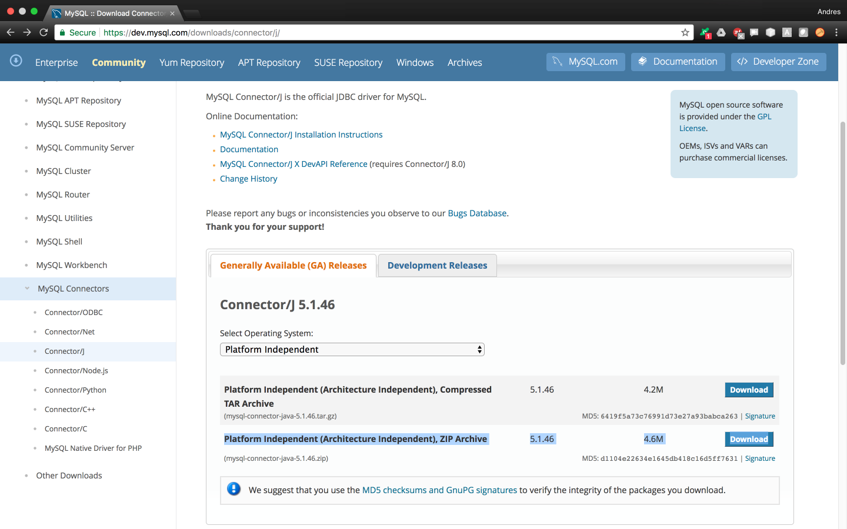

Now go to your Downloads folder and unzip the MySQL connector.

padawan$ cd /home/padawan/Downloads/

padawan$ unzip mysql-connector-java-5.1.46.zip

Now change directory into the unzipped folder and move the file *mysql-connector-java-5.1.46-bin.jar* into your GlassFish’s lib folder.

padawan$ cd /home/padawan/Downloads/mysql-connector-java-5.1.46

padawan$ sudo mv mysql-connector-java-5.1.46-bin.jar /usr/share/glassfish4/glassfish/lib/

Now make sure the MySQL connector .jar file is where it is supposed to be.

padawan$ sudo ls /usr/share/glassfish4/glassfish/lib/

appclient       dtds           javaee.jar                           nadmin.bat

appserv-rt.jar  embedded       jndi-properties.jar                  package-appclient.xml

asadmin         endorsed       monitor                              registration

client          gf-client.jar  mysql-connector-java-5.1.46-bin.jar  schemas

deployment      install        nadmin

Finally, restart your GlassFish server.

padawan$ sudo /etc/init.d/glassfish restart

Waiting for the domain to stop .

Command stop-domain executed successfully.

Waiting for domain1 to start .......

Successfully started the domain : domain1

domain  Location: /usr/share/glassfish4/glassfish/domains/domain1

Log File: /usr/share/glassfish4/glassfish/domains/domain1/logs/server.log

Admin Port: 4848

Command start-domain executed successfully.

## Create a New Connection Pool on GlassFish

Open GlassFish admin console and select *JDBC Connection Pools* from the menu on the left.

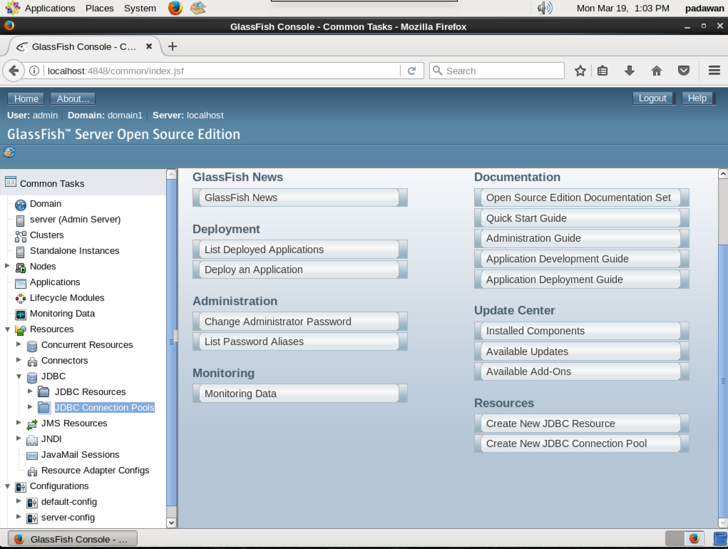

Click on ‘*New*’ to create a new connection pool

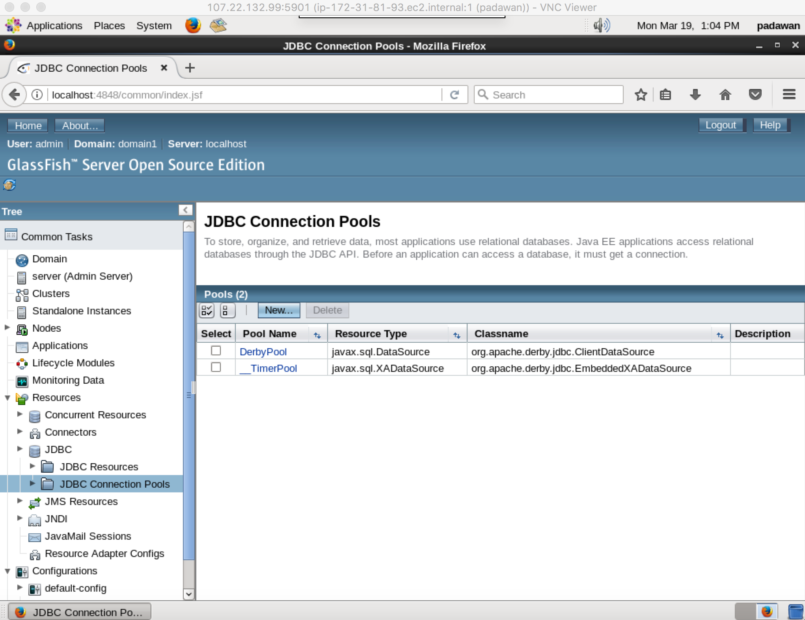

Proceed to fill the 1st page that pops up following the example below. Replace the ‘Pool Name’ field with your application’s own pool name.

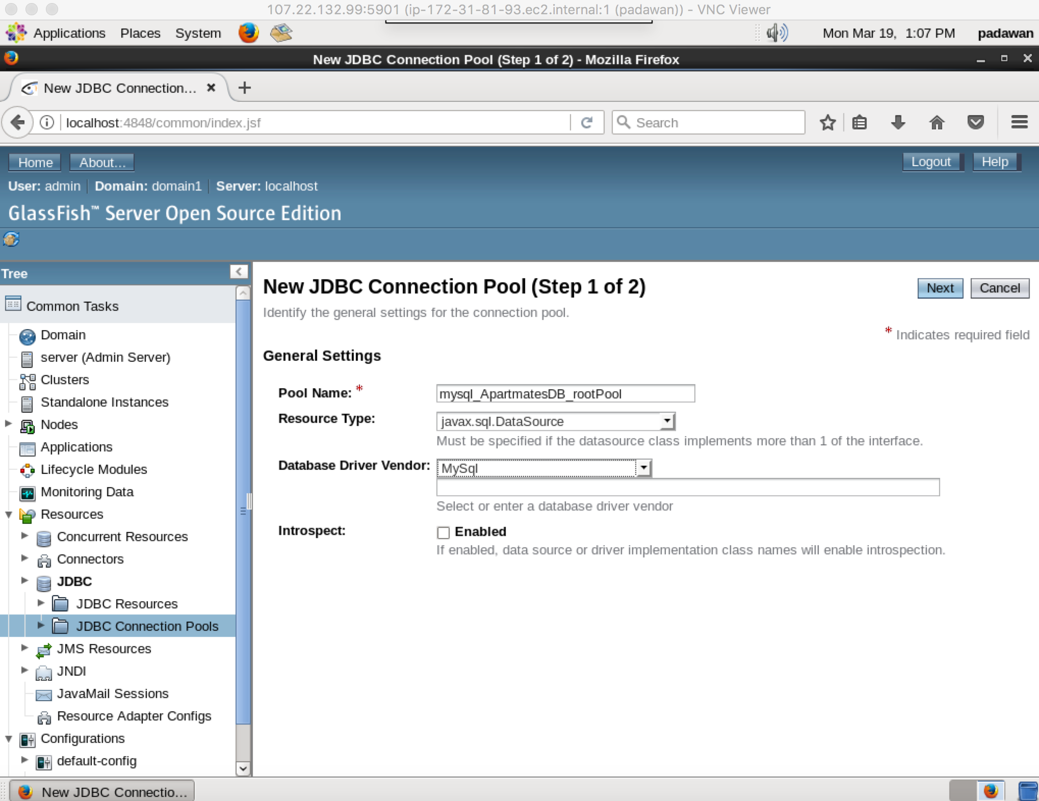

Now fill the first half of the 2nd page accordingly.

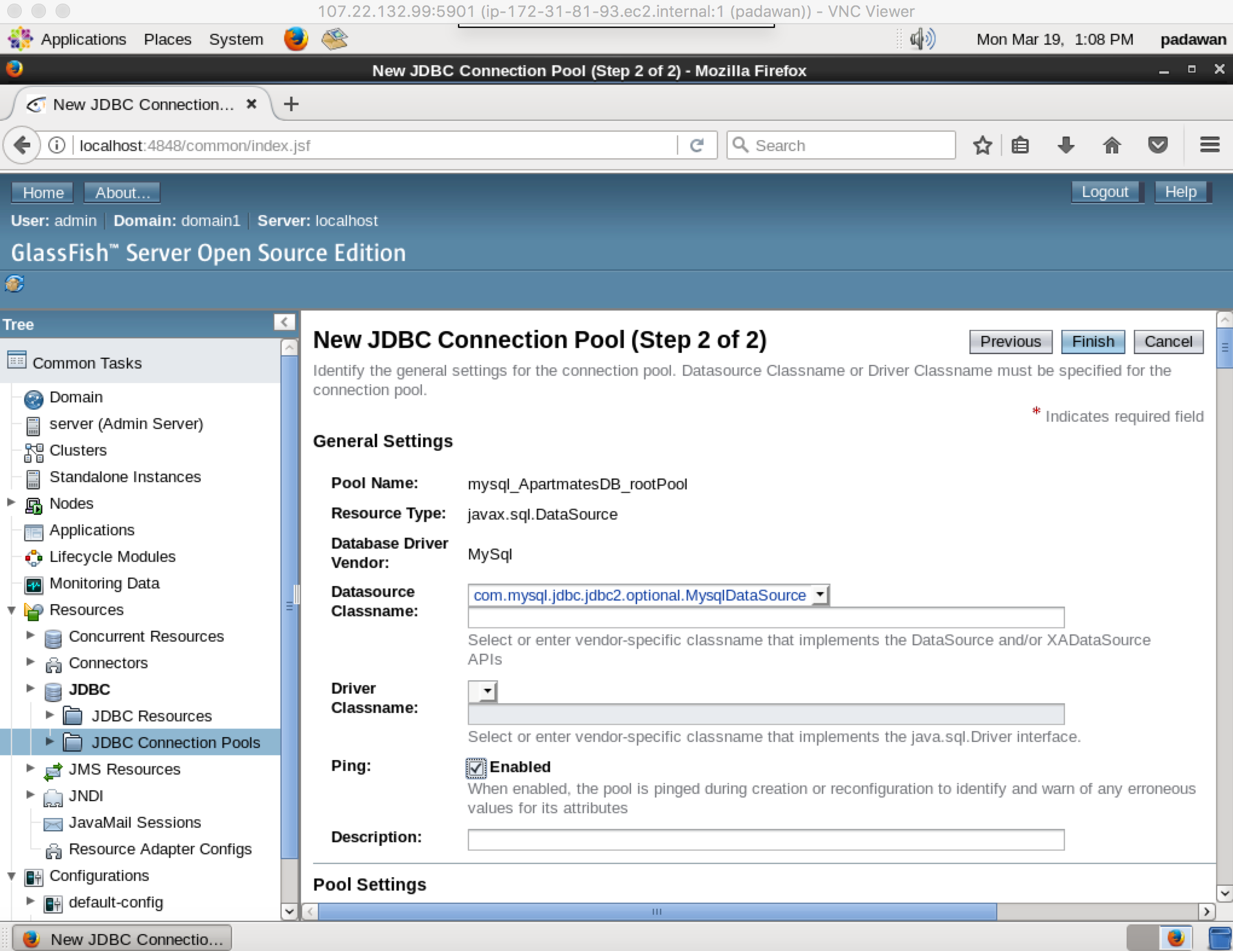

But before clicking finish. Scroll down to the bottom of the page, and fill the following fields with their respective values as shown below:

Port: 3306

DatabaseName: ApartmatesDB

Password: CSD@mysql-1872

URL: jdbc:mysql://localhost:3306/ApartmatesDB?zeroDateTimeBehavior=convertToNull

Url: jdbc:mysql://localhost:3306/ApartmatesDB?zeroDateTimeBehavior=convertToNull

ServerName: localhost

PortNumber: 3306

User: root

If everything worked correctly, you should see the following screen with the message ‘*Ping Succeeded*’.

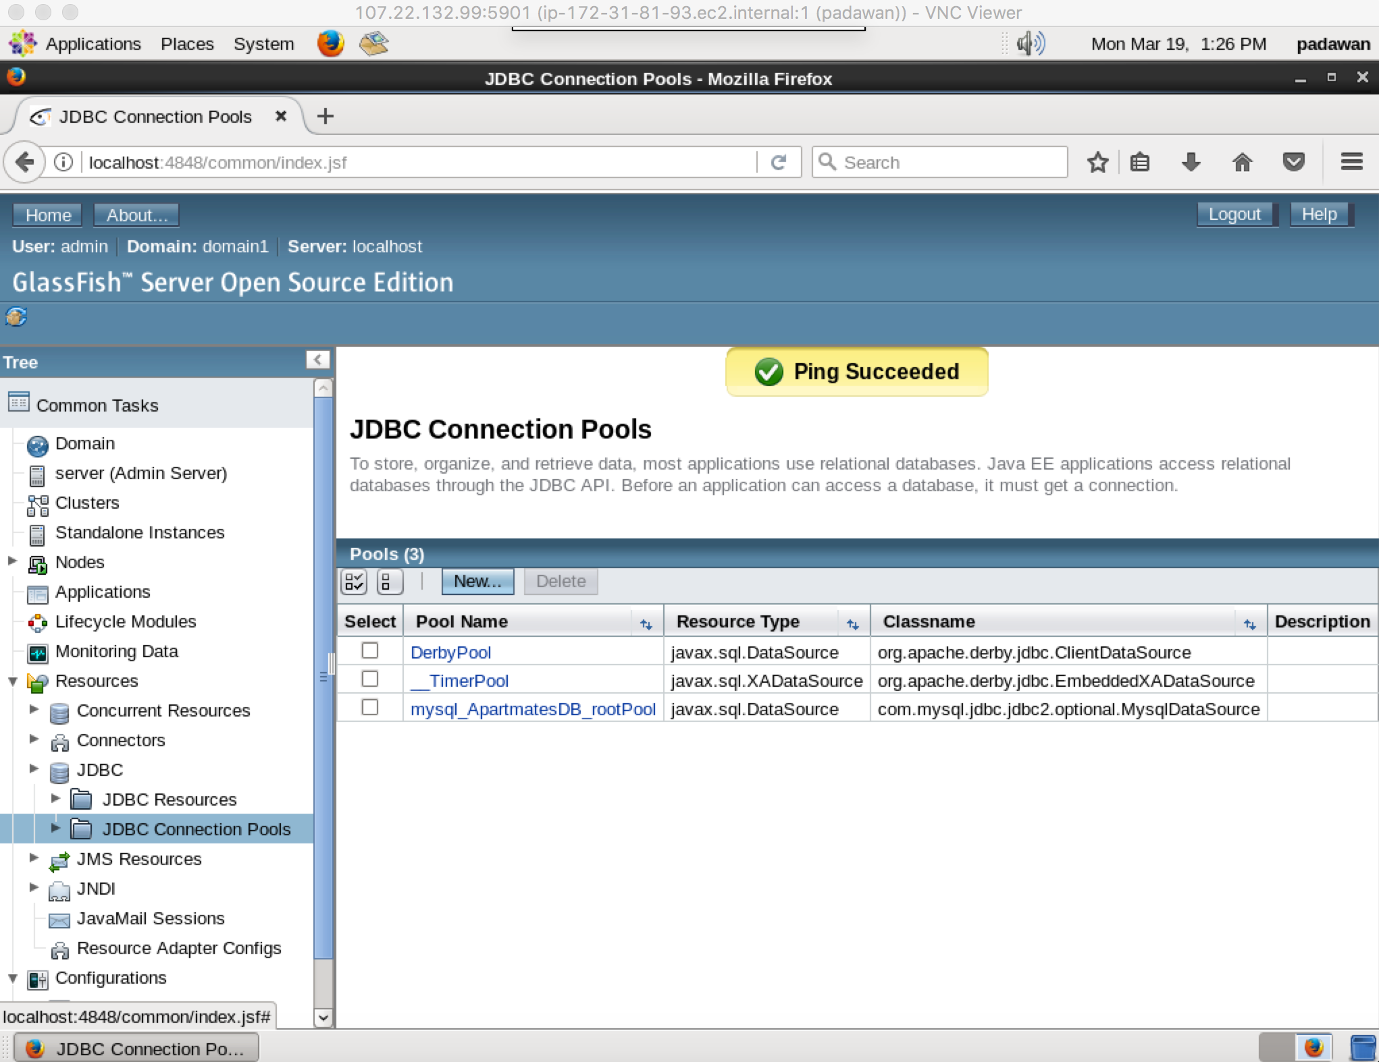

## Create New JDBC Resource on GlassFish

Open your GlassFish admin console and select *JDBC Resources* at the menu on the left. Then click on ‘*New*’ to create a New JDBC resource.

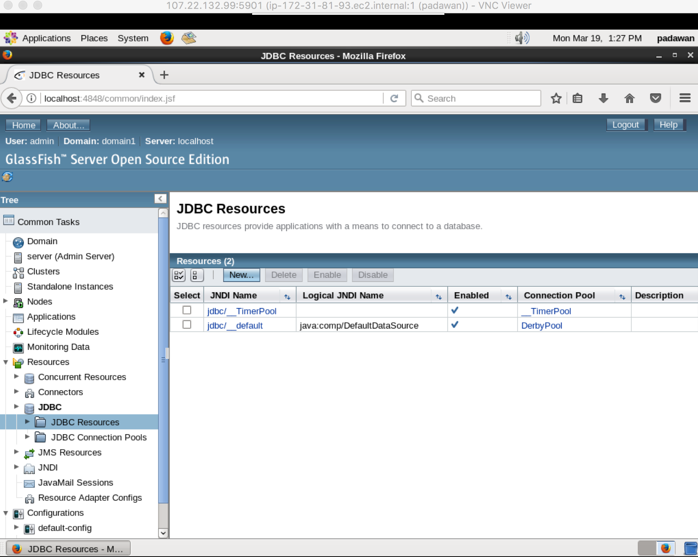

Proceed to fill the page that pops up following the example below. Replace the ‘*JNDI Name*’ field with your application’s own JNDI name.

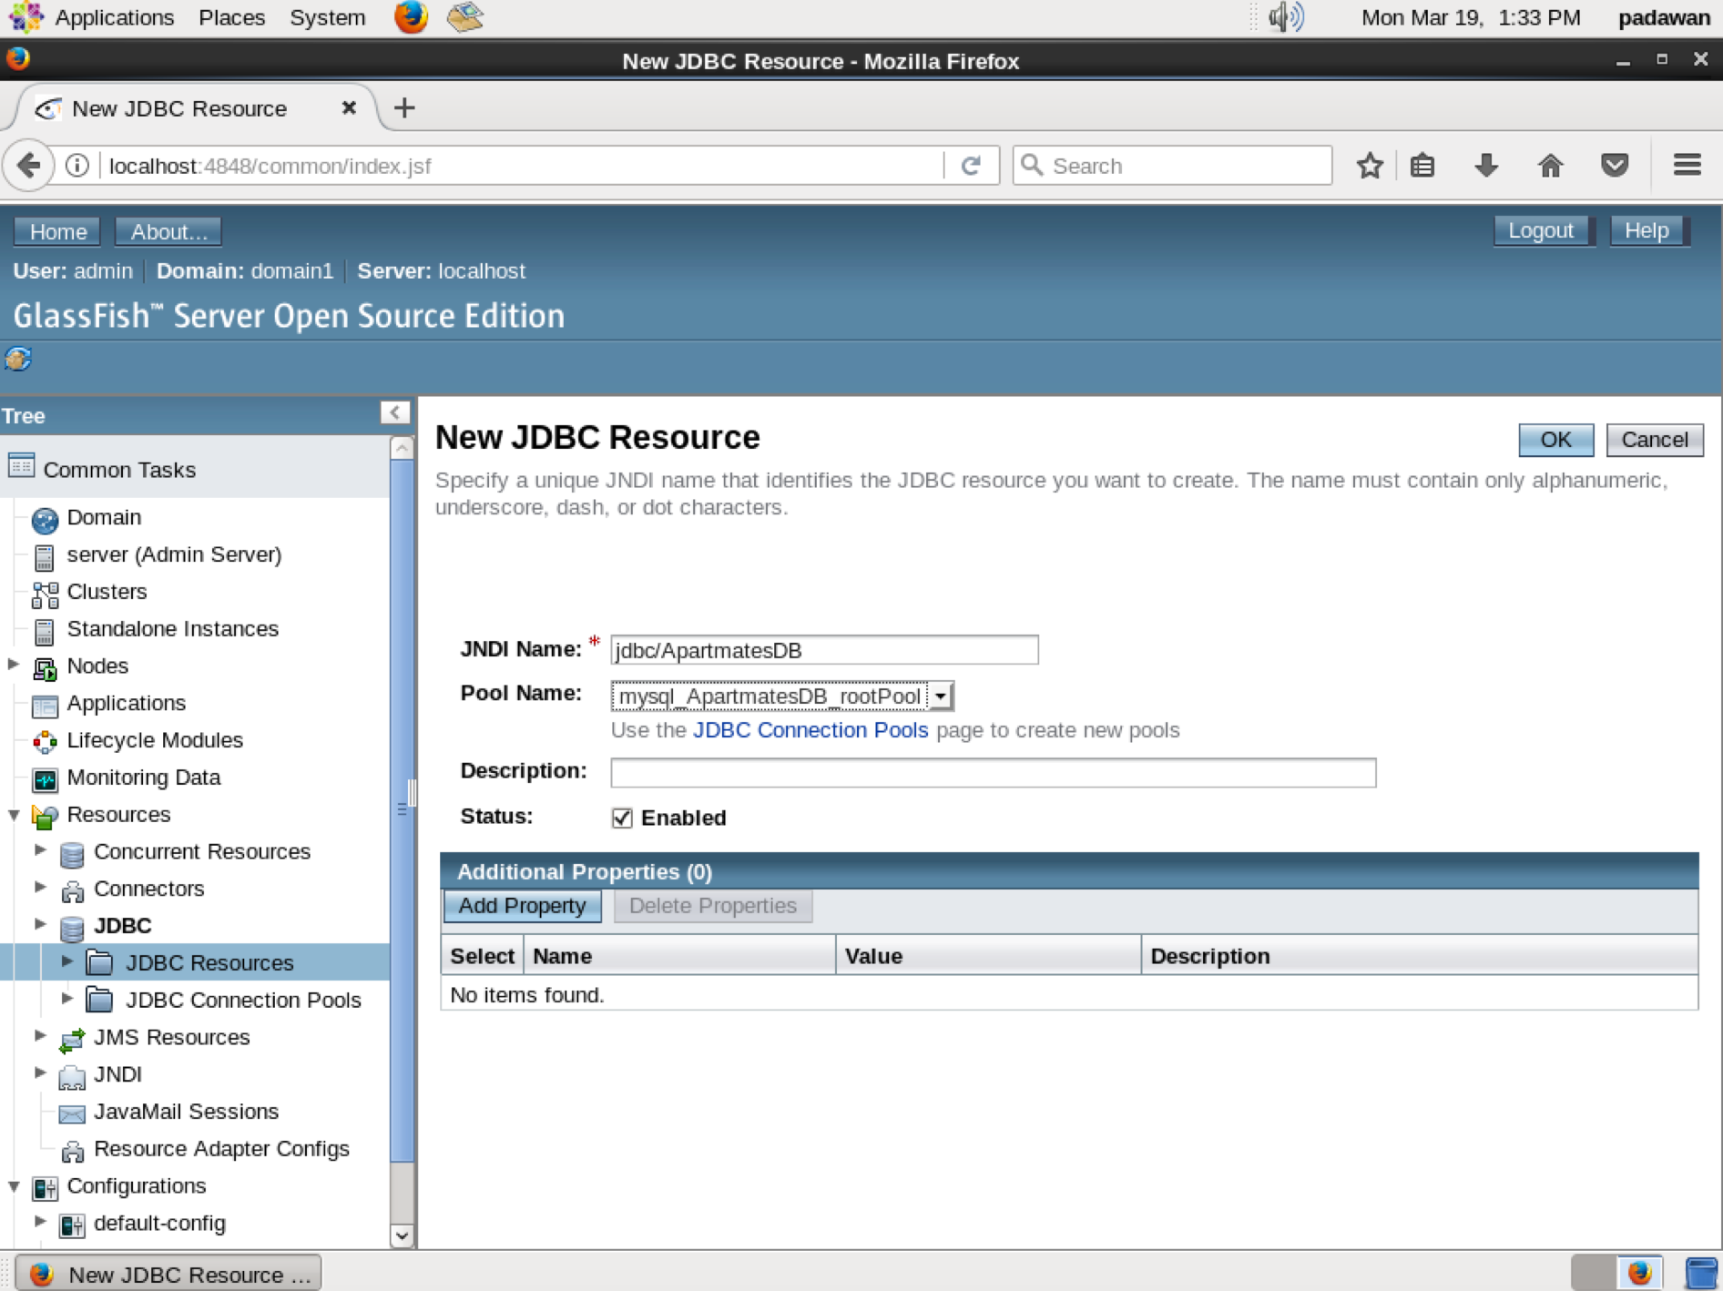

Finally, you should see your new JDBC resource added to the list below.

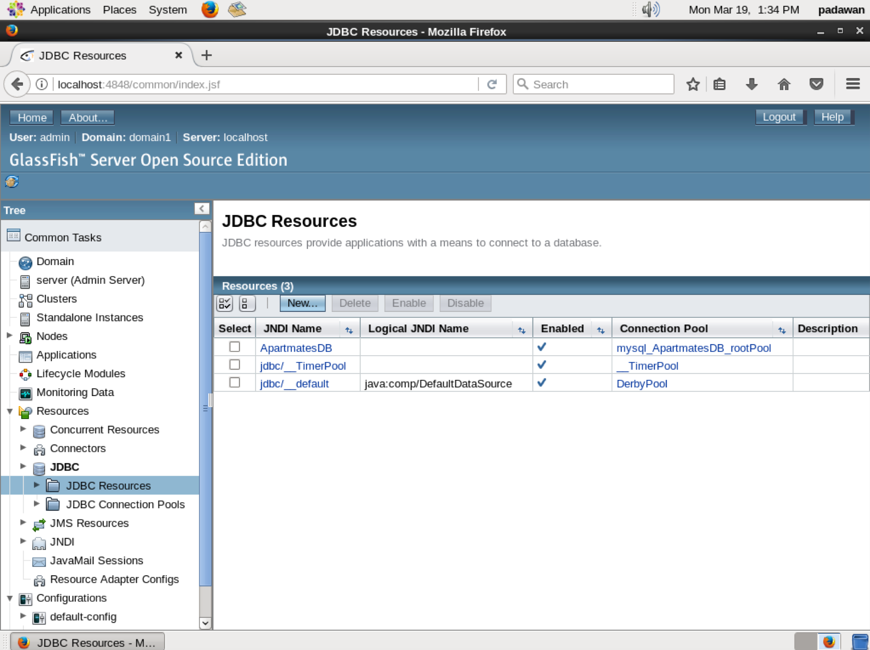

# STEP 7: Allocate an Elastic (Static) IP Address for Your Amazon VPS and Set up Your Domain

We’re almost done! But before deploying our cloud software application, we need to set an AWS elastic IP address, which just means that we’ll set a static IP address to your VPS that won’t change over time. Afterwards, your application will always be reachable with the same IP address.

## Allocate New Elastic IP Address

Open your web browser and access the following AWS tutorial:

<https://aws.amazon.com/getting-started/tutorials/get-a-domain/>

Then scroll down to “*Step 1: Obtain a Static URL*” and follow the instructions.

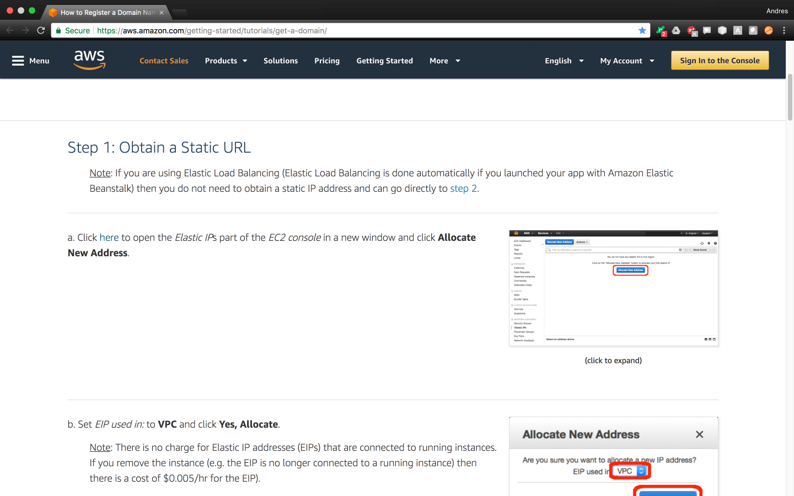

After following the steps you’ll be presented with your new Elastic IP address.

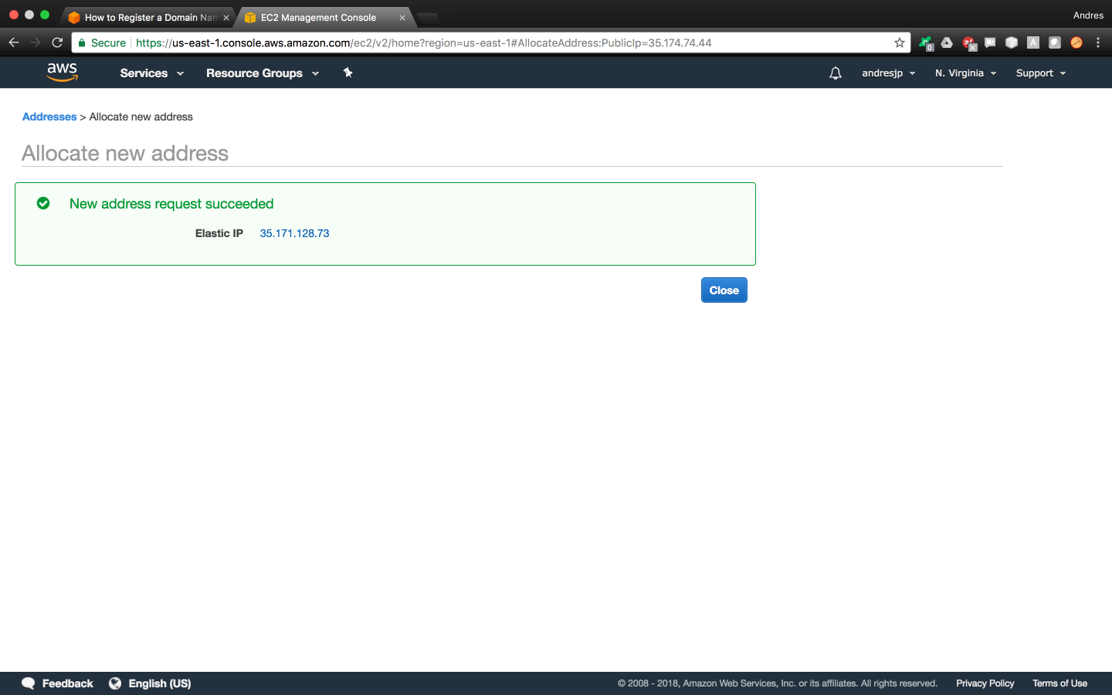

You’ll notice however that your Elastic IP address has not yet been associated with an EC2 instance though.

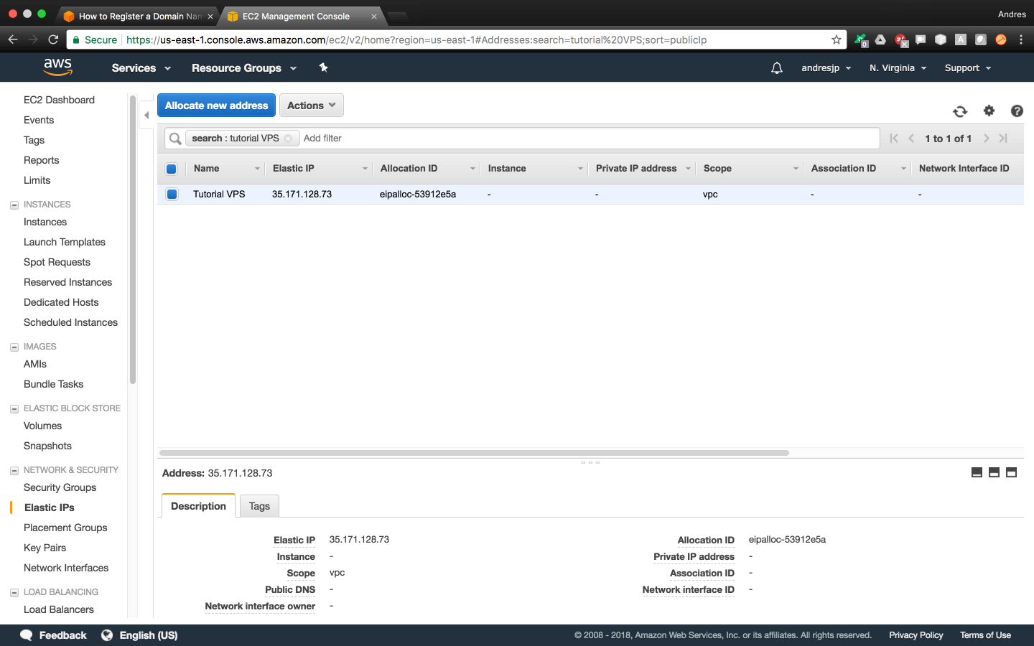

Select the IP address above and take the action to associate it with your desired EC2 instance

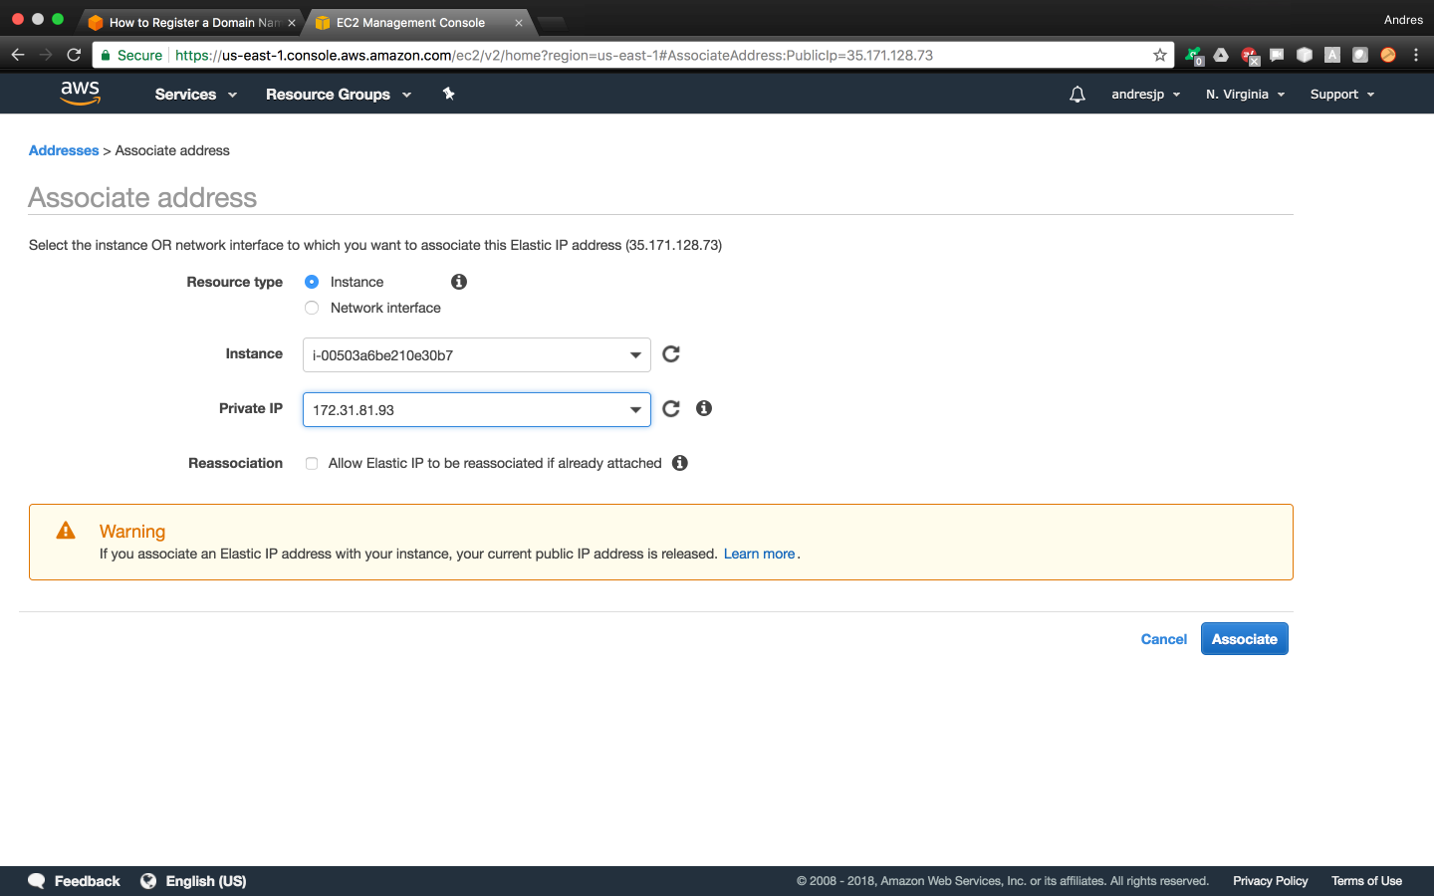

Now you’ll be able to see that your IP address has been associated with your instance

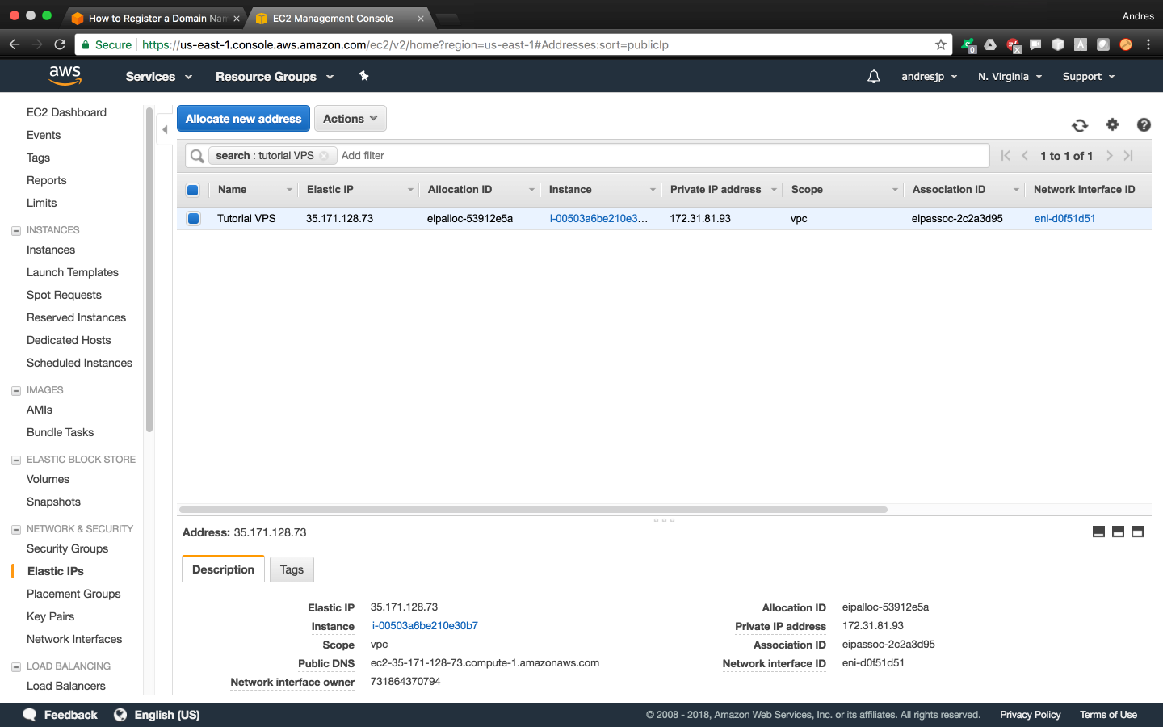

Go to your EC2 console and you’ll see the changes reflected on your instance as well

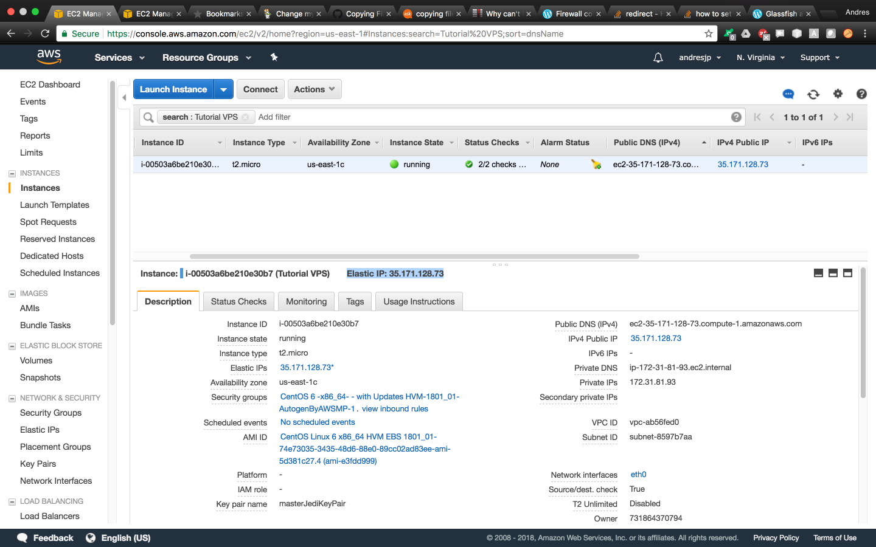

Note that you’ll have to use your new Elastic IP address to SSH into your from now on.

localcomputer$ ssh -i "~/.ssh/masterJediKeyPair.pem" centos@35.171.128.73

The authenticity of host '35.171.128.73 (35.171.128.73)' can't be established.

RSA key fingerprint is SHA256:/+O6KCLXU2mk5sUlQQevcwDoYX9UntppqxGcewIZ+30.

Are you sure you want to continue connecting (yes/no)? yes

Warning: Permanently added '35.171.128.73' (RSA) to the list of known hosts.

Last login: Mon Mar 19 00:53:47 2018 from 71.62.158.142

[centos@ip-172-31-81-93 ~]$

## Obtain and Use a Domain Name for Your VPS

**Obtaing a domain name is optional.** You can always use your application with the IP address. However, if you wish to do it professionally, certainly a domain name is needed.

Open your web browser and access the following AWS tutorial:

<https://aws.amazon.com/getting-started/tutorials/get-a-domain/>

In order to set a domain for your VPS, you’ll need to scroll down the page and complete steps 2 and 3.

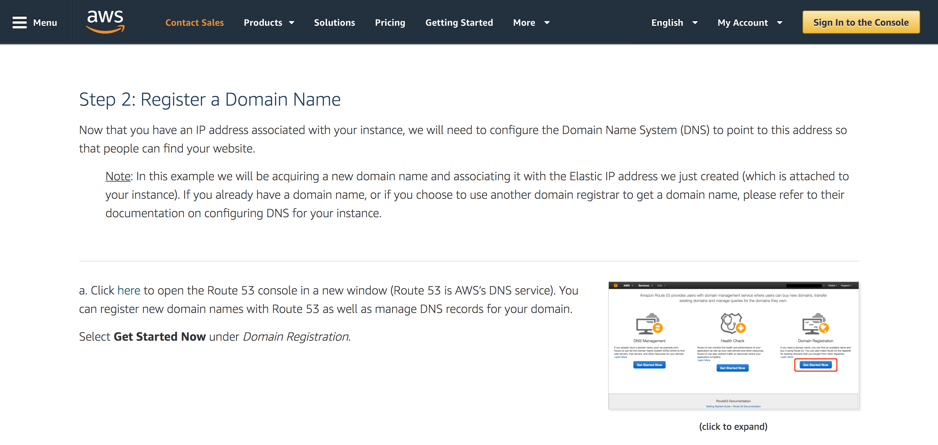

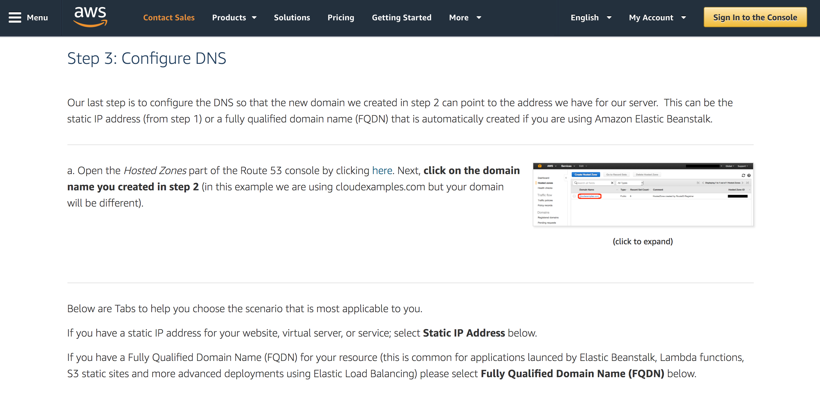

Alternatively, there are many vendors that you could use to obtain your domain name from, and each vendor has its own way of linking your domain with your static IP address. For example, GoDaddy allows you to get your first domain for only $1. If you do decide to get your domain from GoDaddy you can follow their tutorial to configure DNS:

<https://uk.godaddy.com/help/change-my-ip-address-20134>

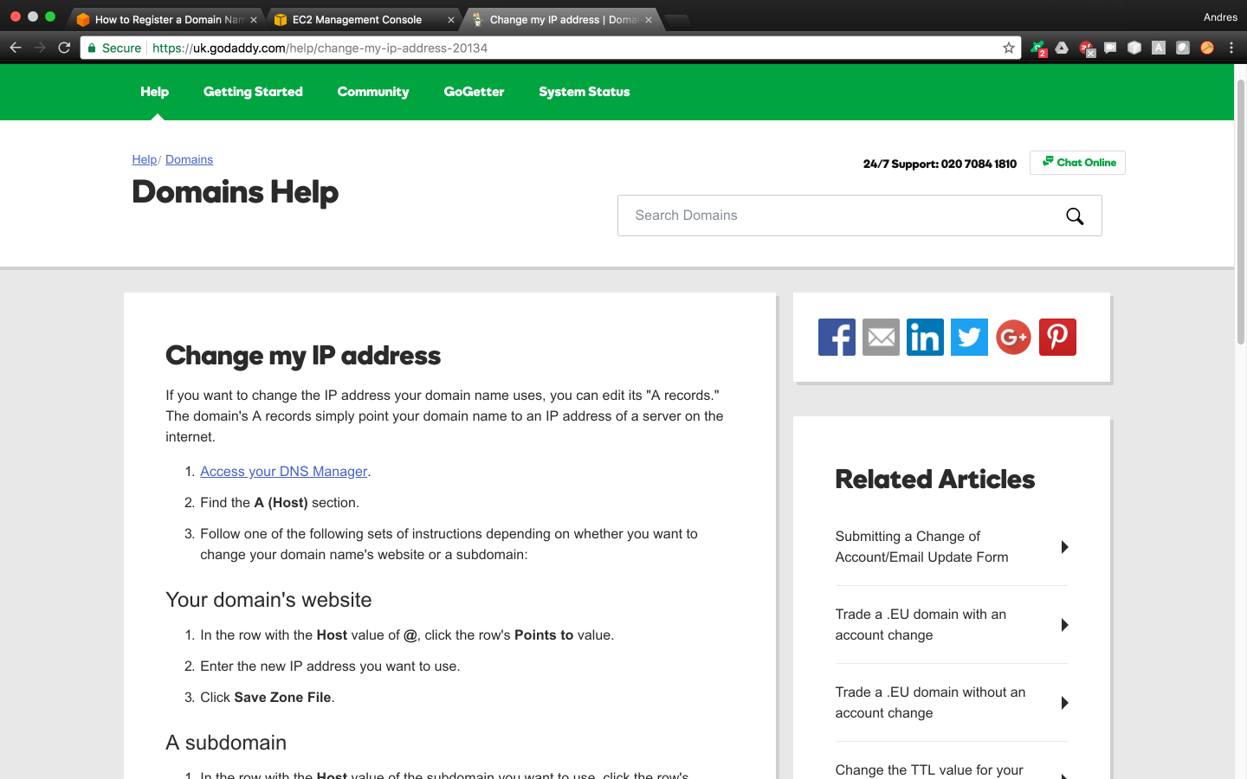

# STEP 8: Copying WAR Files to Your VPS

After GlassFish and MySQL have been installed, and after you have configured MySQL on GlassFish, we just need to get our WAR files into our VPS to deploy them. We can easily do this by following the script below.

## Copy Your WAR File Using SCP

The easiest way to transfer our WAR files into our VPS in a secure manner, is by using the linux ‘scp’ command which transfer files between hosts by using Secure SHell (SSH).

If you haven’t done so, make the following directories from the *padawan* user. We’ll store your cloud software application’s WAR file in here.

padawan$ mkdir /home/padawan/Netbeans_Projects

padawan$ mkdir /home/padawan/Netbeans_Projects/ApartMates

If you haven’t done so, make the following directory in the default centos user. We’ll receive the transferred WAR files in this location.

padawan$ su - centos

[centos@ip-172-31-81-93 ~]$ mkdir Netbeans_Projects

Next, run the following command from your local computer’s terminal. This will transfer your WAR files to your VPS under the directory we just created.

localcomputer$ scp -i "~/.ssh/masterJediKeyPair.pem" /Users/*<your_username>*/NETBEANS_PROJECTS/ApartMates/Apartmates/dist/Apartmates.war centos@35.171.128.73:~/Netbeans_Projects/

At this point, we’ll move the WAR files we just received into its corresponding cloud software application folder.

centos$ sudo mv ~/Netbeans_Projects/Apartmates.war /home/padawan/Netbeans_Projects/ApartMates/ && sudo chown padawan:padawan /home/padawan/

Finally, make sure the war file has been transferred to the right location.

padawan$ ls /home/padawan/Netbeans_Projects/ApartMates/

Apartmates.war

# STEP 9: Deploy Your Cloud Software Application Using GlassFish

Now finally you’ve made it to the end of the road! It’s time to deploy our cloud software application to the public internet and for it to be accessible by anyone!

## Open EC2 Instance Ports

If you haven’t done so yet, you have to open your http, https, and the GlassFish default ports to allow incoming connections to your cloud software application. This needs to be done only once.

Open your EC2 Console, locate your instance, and scroll all the way to the right to find your instance’s security groups. Then click on it.

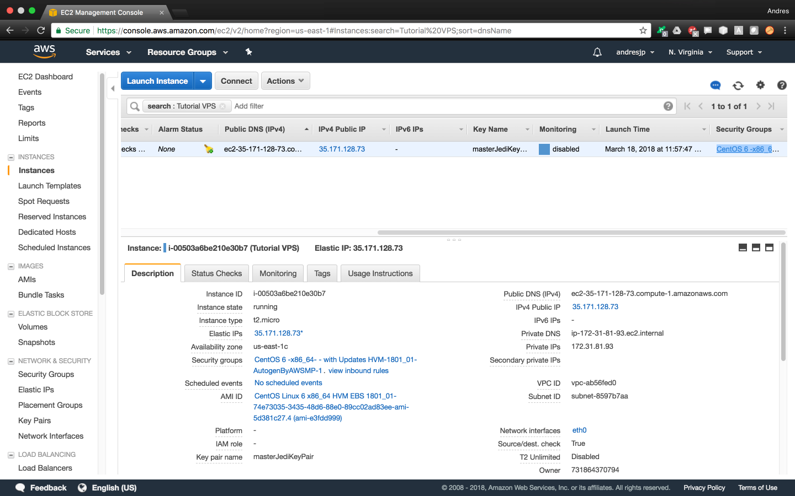

Now that you’ve accessed your instance’s security groups, you want to select the ‘Inbound’ tab and then click on ‘Edit’.

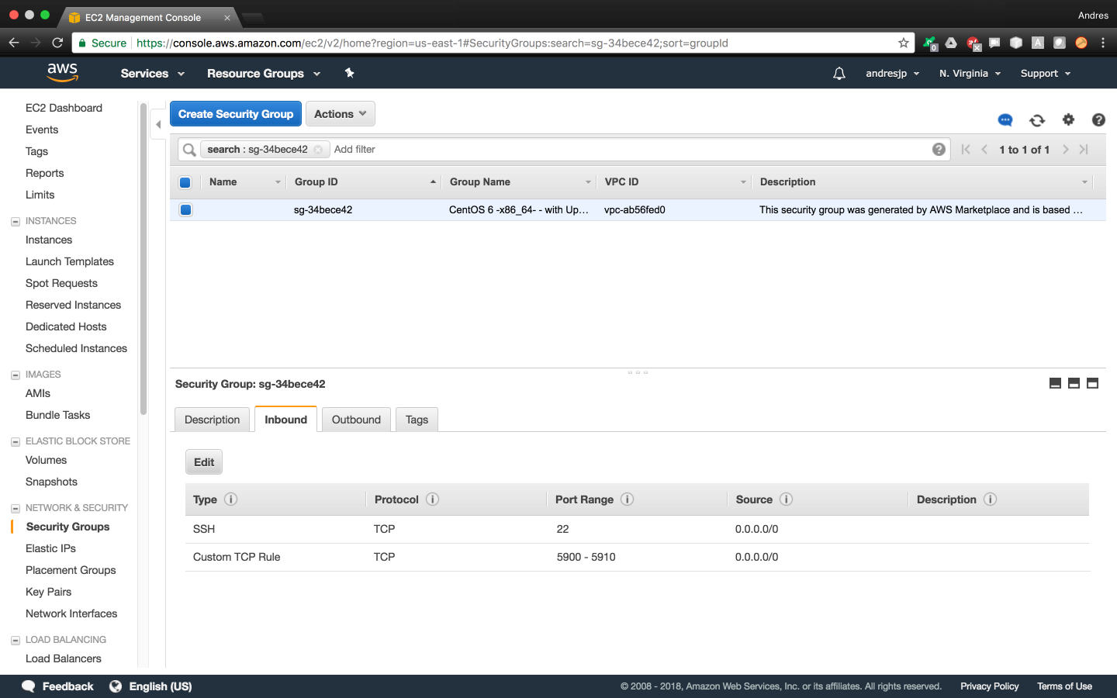

Add the following rules for HTTP, HTTPS, and the GlassFish Default Port

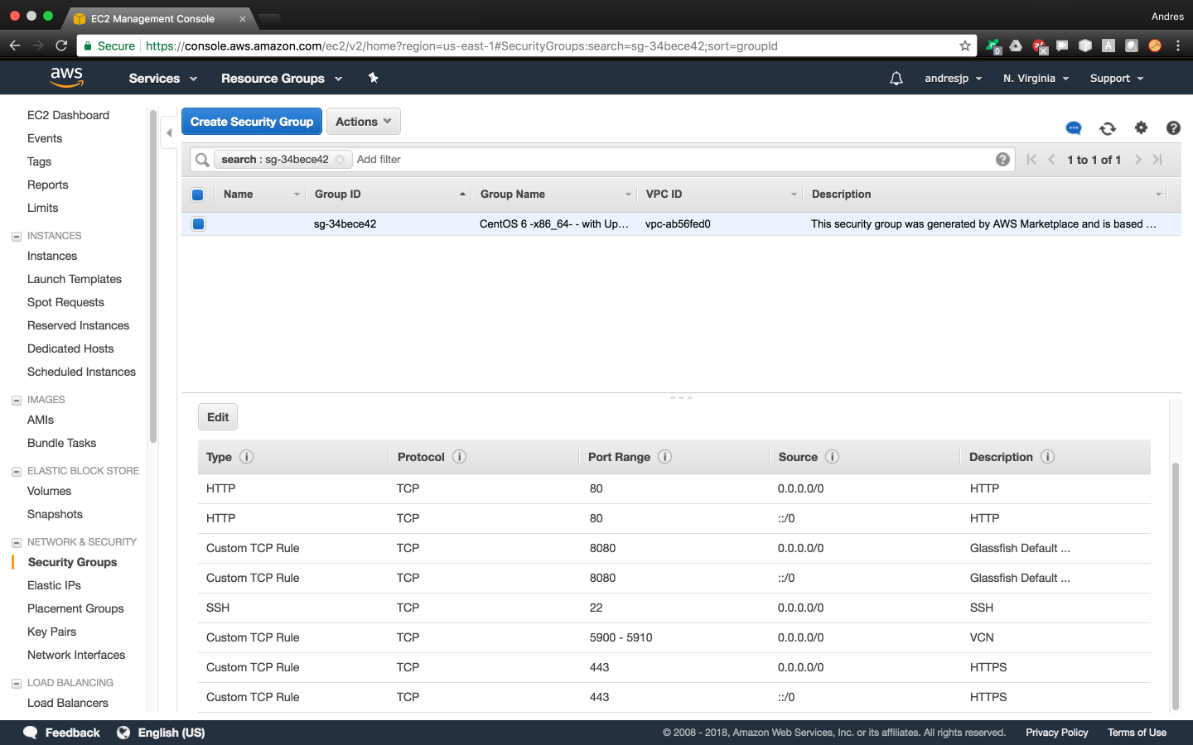

Finally, reboot your instance for changes to take effect.

## Open VPS Firewall Ports

In addition to allowing incoming connections from your EC2 console, we need to allow incoming connections from our VPS firewall.

Open your VPS terminal as the root user and run the script below to allow incoming connections to your HTTP port.

root$ iptables -I INPUT 5 -m state --state NEW -p tcp --dport 80 -j ACCEPT

root$ sudo service iptables save

iptables: Saving firewall rules to /etc/sysconfig/iptables:[  OK  ]

root$ sudo service iptables restart

iptables: Setting chains to policy ACCEPT: filter          [  OK  ]

iptables: Flushing firewall rules:                         [  OK  ]

iptables: Unloading modules:                               [  OK  ]

iptables: Applying firewall rules:                         [  OK  ]

Now run the script below to allow incoming connections to your HTTPS port.

root$ iptables -I INPUT 5 -m state --state NEW -p tcp --dport 443 -j ACCEPT

root$ sudo service iptables save

iptables: Saving firewall rules to /etc/sysconfig/iptables:[  OK  ]

root$ sudo service iptables restart

iptables: Setting chains to policy ACCEPT: filter          [  OK  ]

iptables: Flushing firewall rules:                         [  OK  ]

iptables: Unloading modules:                               [  OK  ]

iptables: Applying firewall rules:                         [  OK  ]

Finally, run the script below to allow incoming connections to your glassfish default port.

root$ iptables -I INPUT 5 -m state --state NEW -p tcp --dport 8080 -j ACCEPT

root$ sudo service iptables save

iptables: Saving firewall rules to /etc/sysconfig/iptables:[  OK  ]

root$ sudo service iptables restart

iptables: Setting chains to policy ACCEPT: filter          [  OK  ]

iptables: Flushing firewall rules:                         [  OK  ]

iptables: Unloading modules:                               [  OK  ]

iptables: Applying firewall rules:                         [  OK  ]

Then reboot the server for changes to take effect.

root$ reboot

Broadcast message from centos@ip-172-31-81-93.ec2.internal

(/dev/pts/0) at 15:34 ...

The system is going down for reboot NOW!

## Deploy Your Cloud Software Application

Open your GlassFish admin console and select ‘Deploy an Application’.

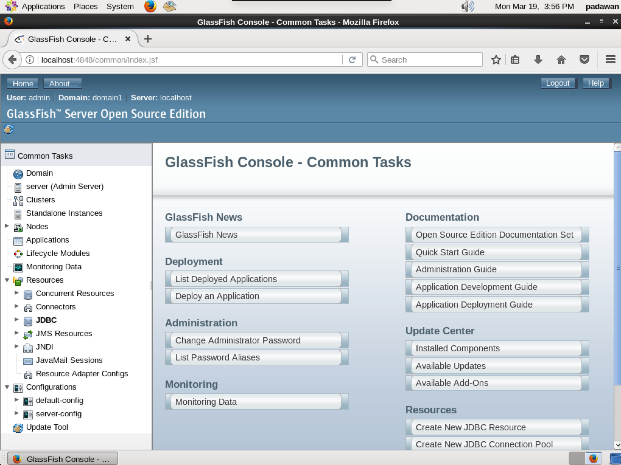

Locate and select your desired cloud software application war file.

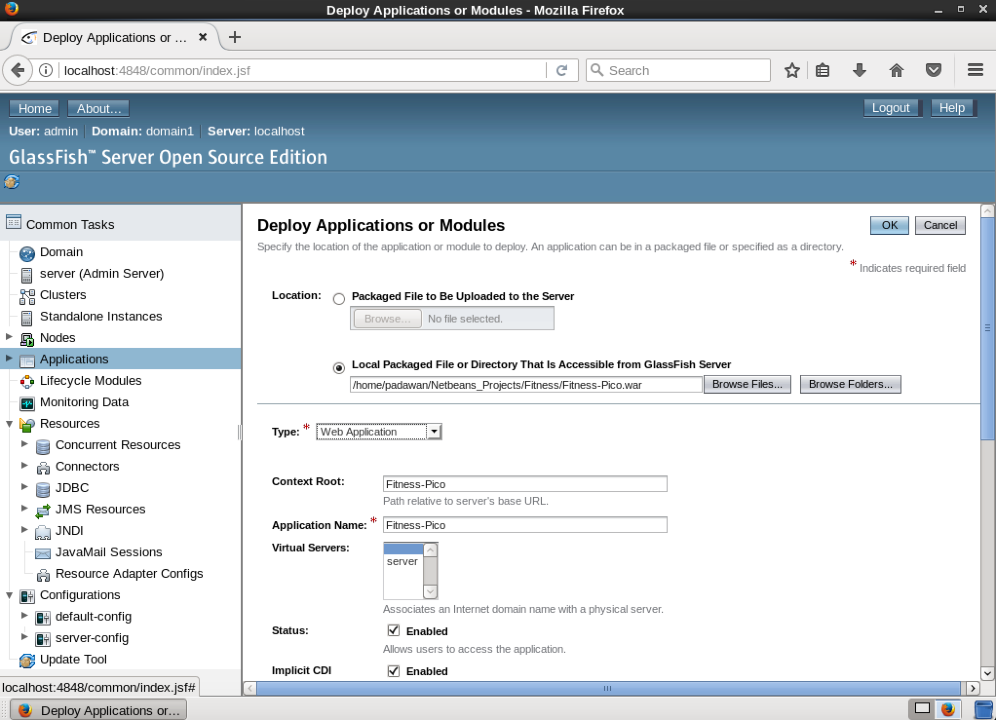

Click ‘OK’ and that’s it! Your application will be deployed.

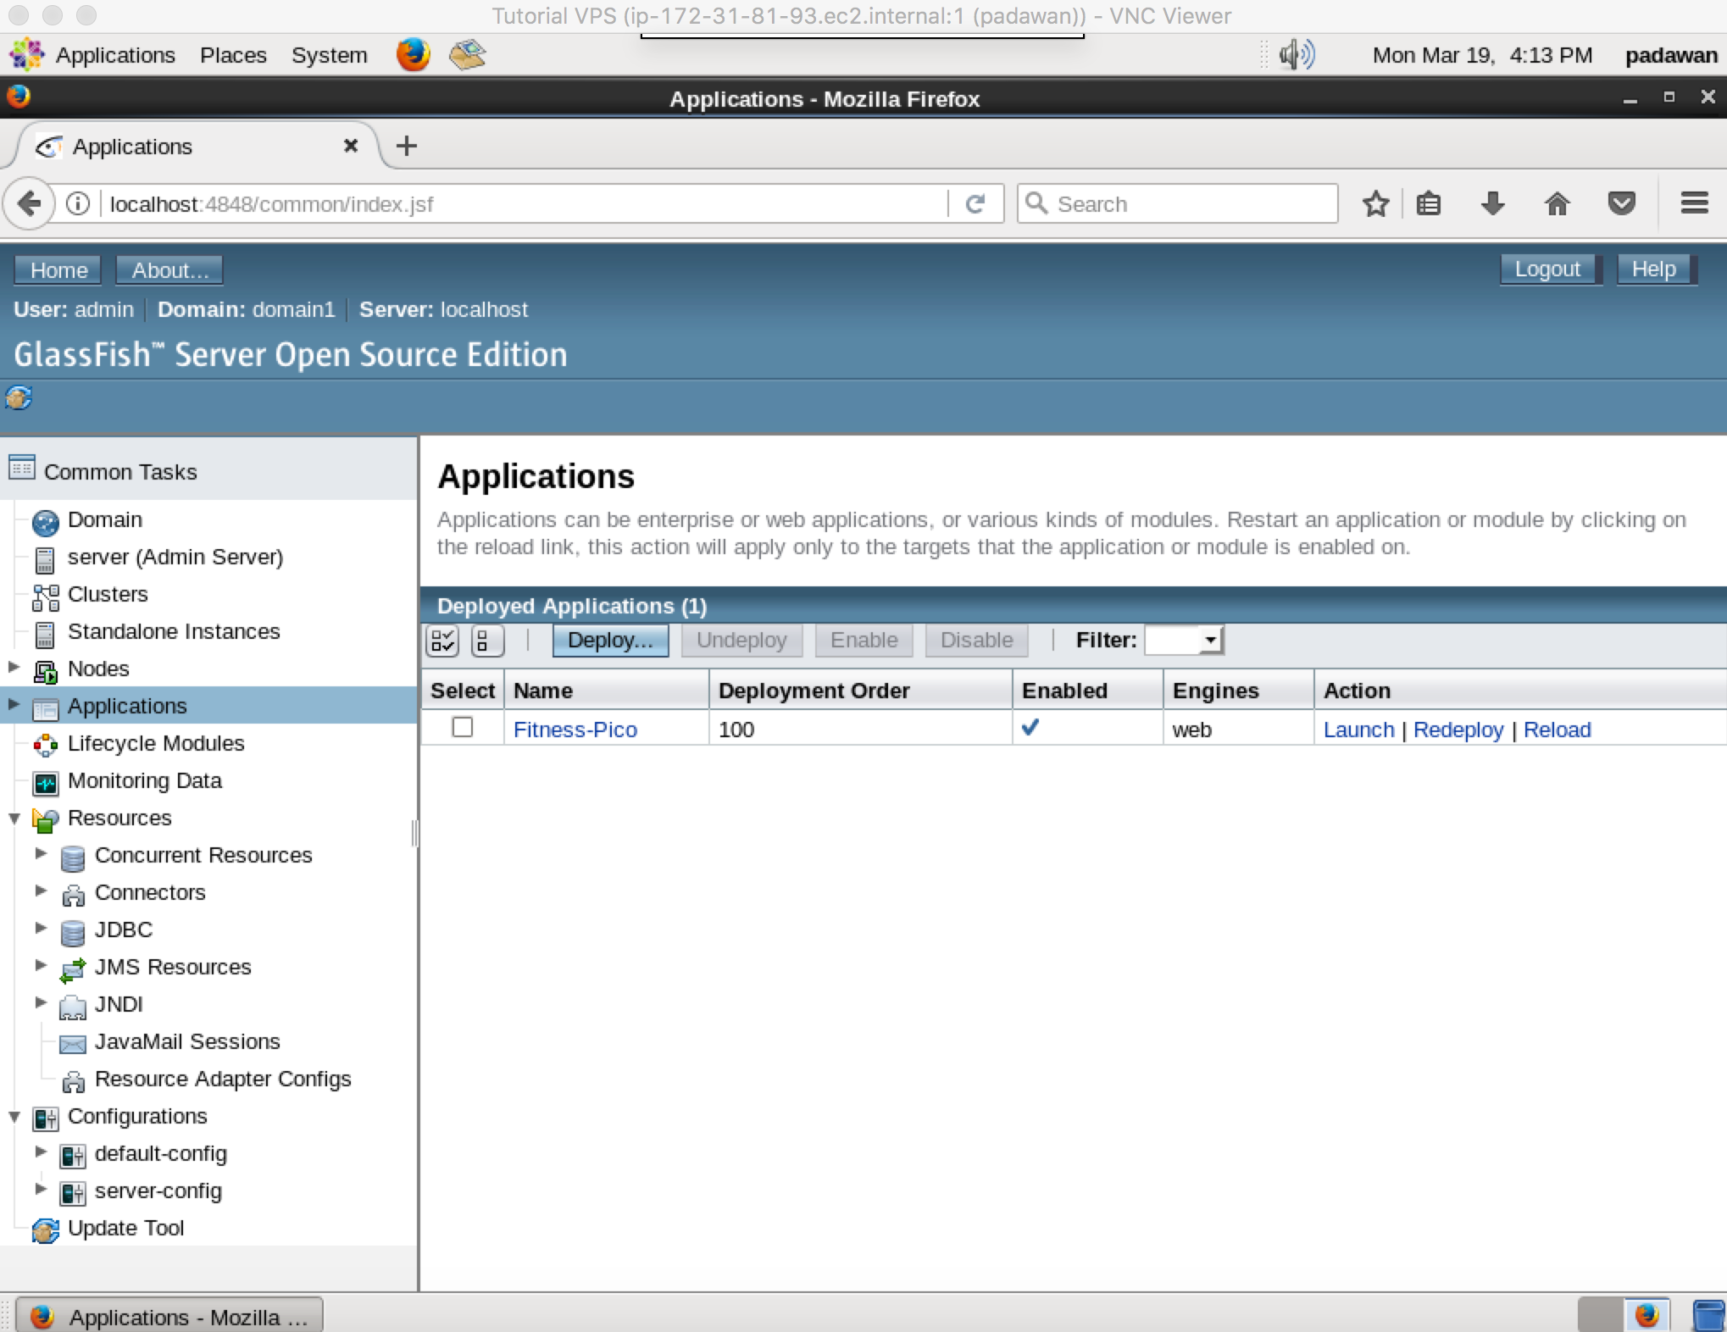

You can open your web browser and visit your software solution now! Congratulations!

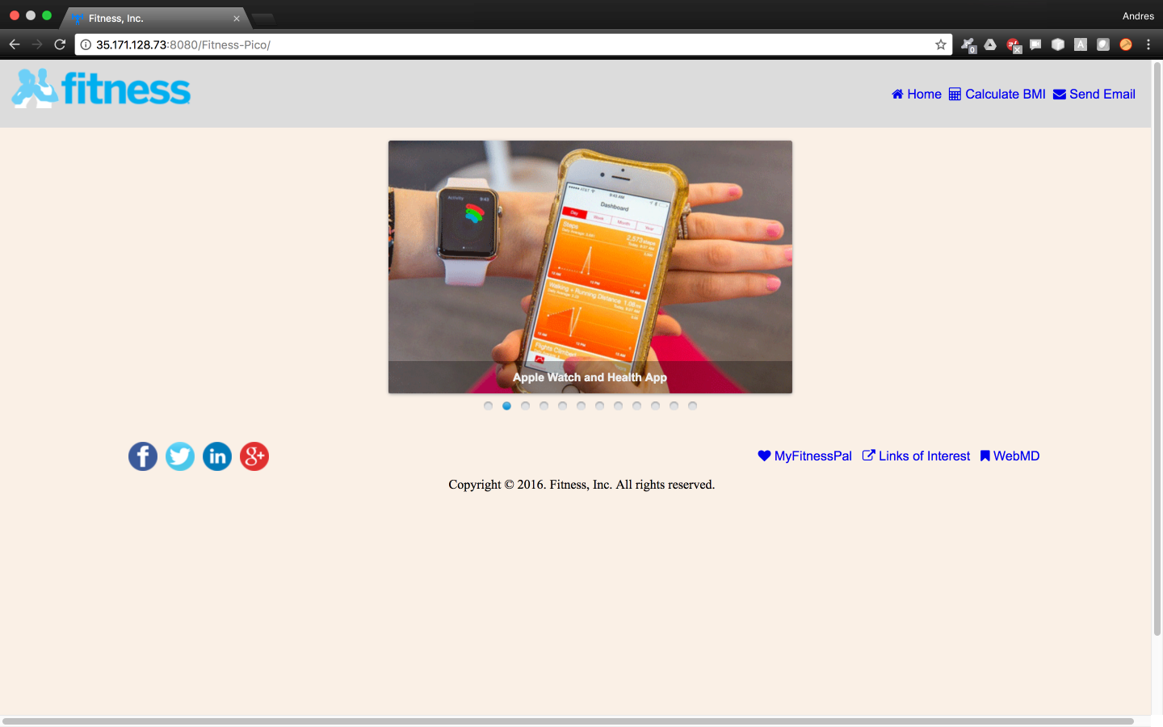

Wait! But before finishing let’s go ahead and remove that ugly port 8080 number from our URL.

## Hide Port 8080

Open your glassfish admin console and select ‘*Configurations* 🡪 *server-config*’ on the left. Then click on ‘*Network Listeners*’.

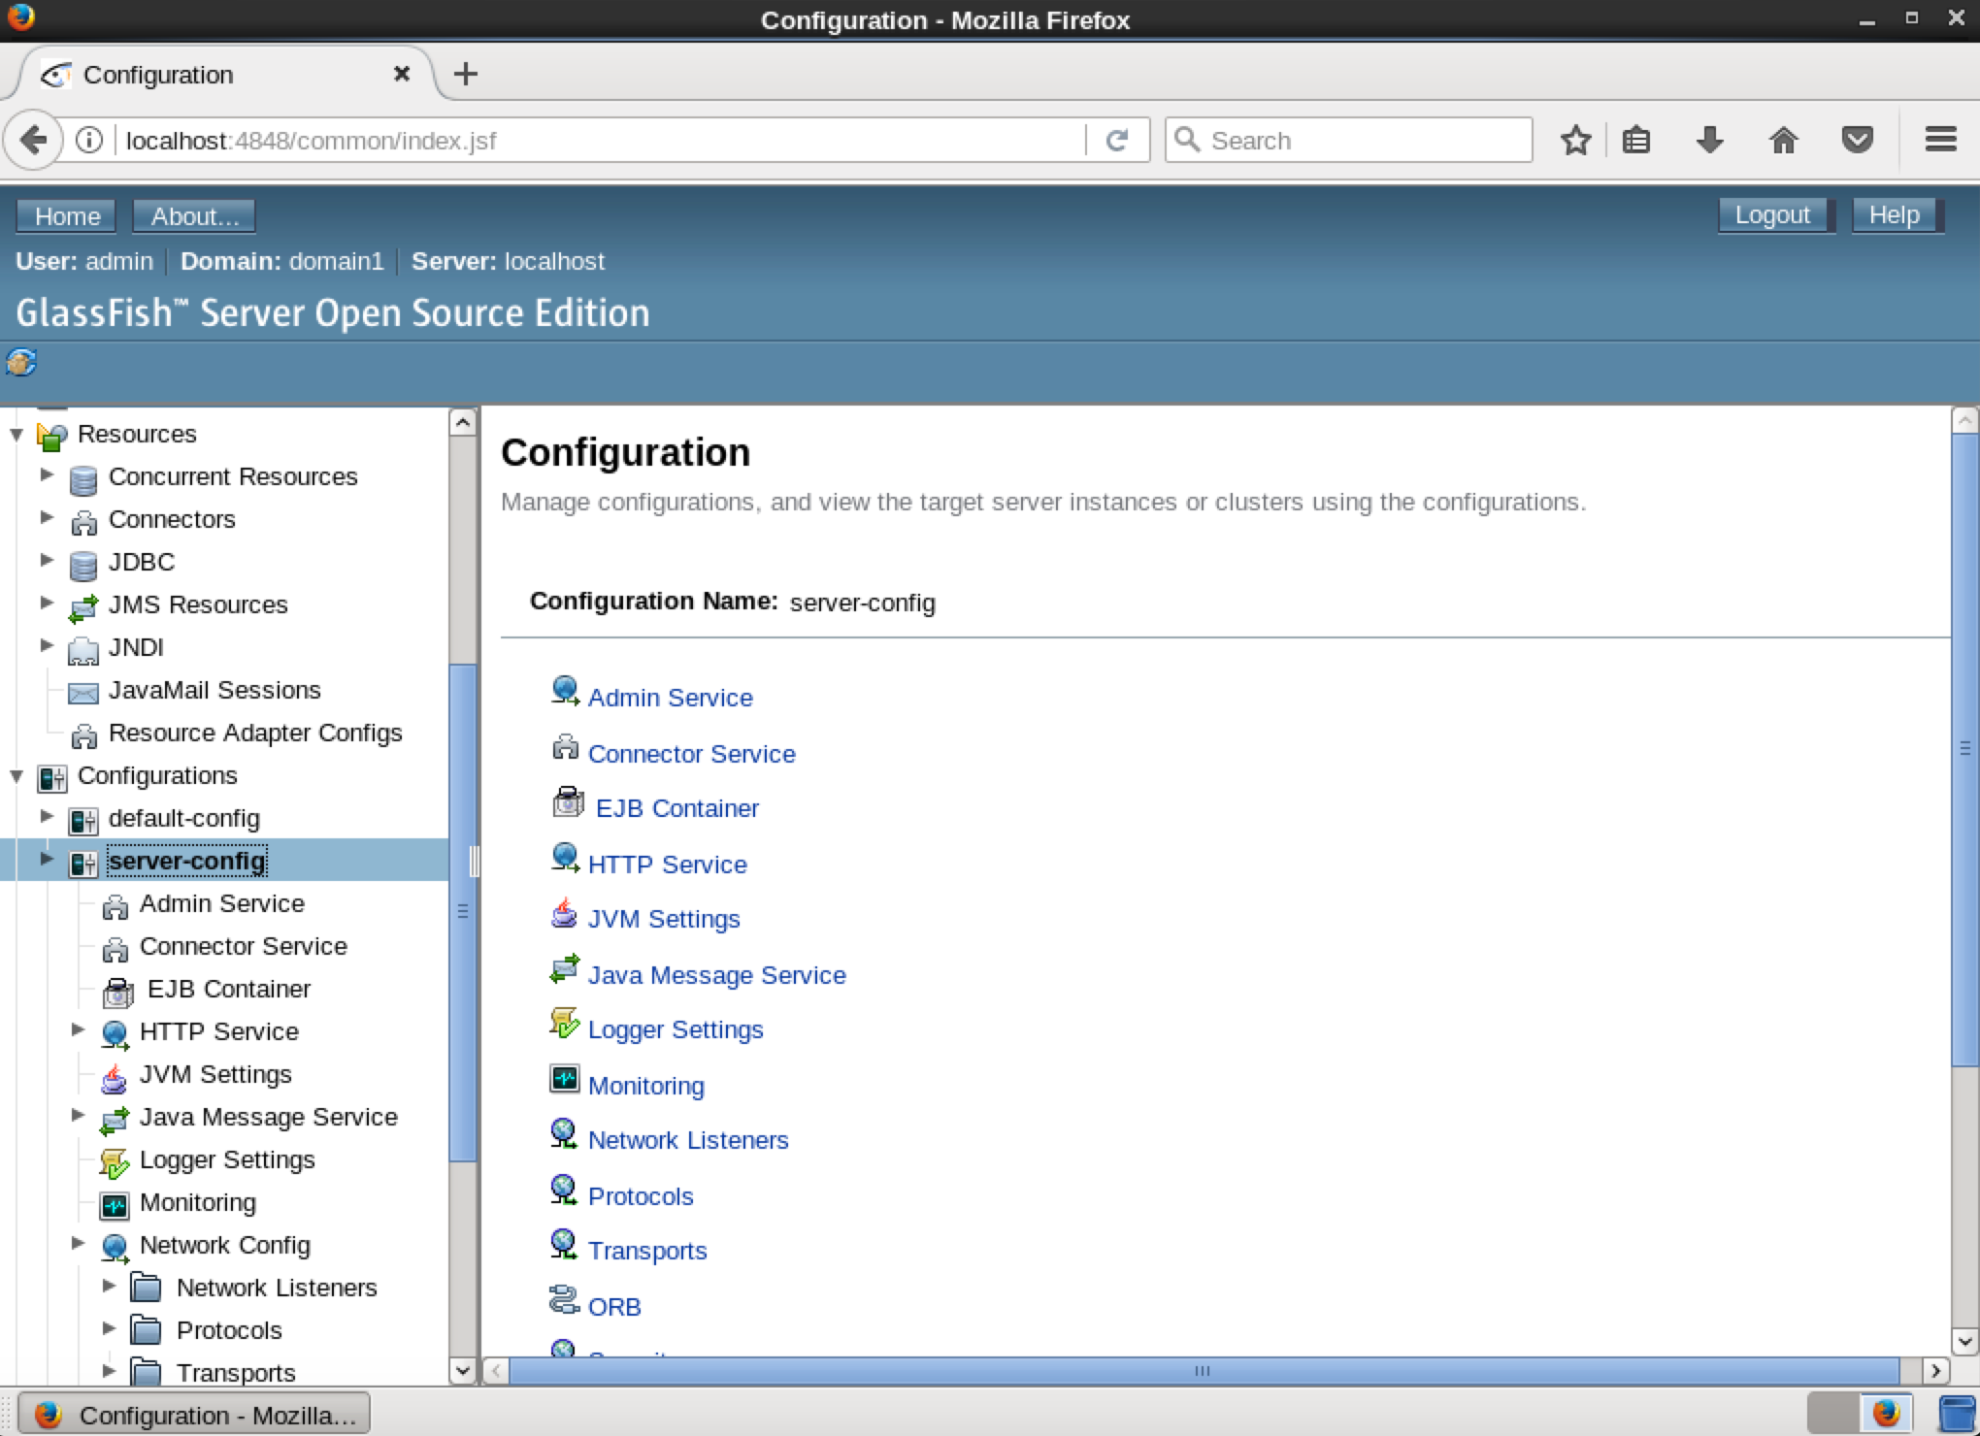

The following screen will appear and you’ll notice that our GlassFish server is listening to ports 8080 and 8081.

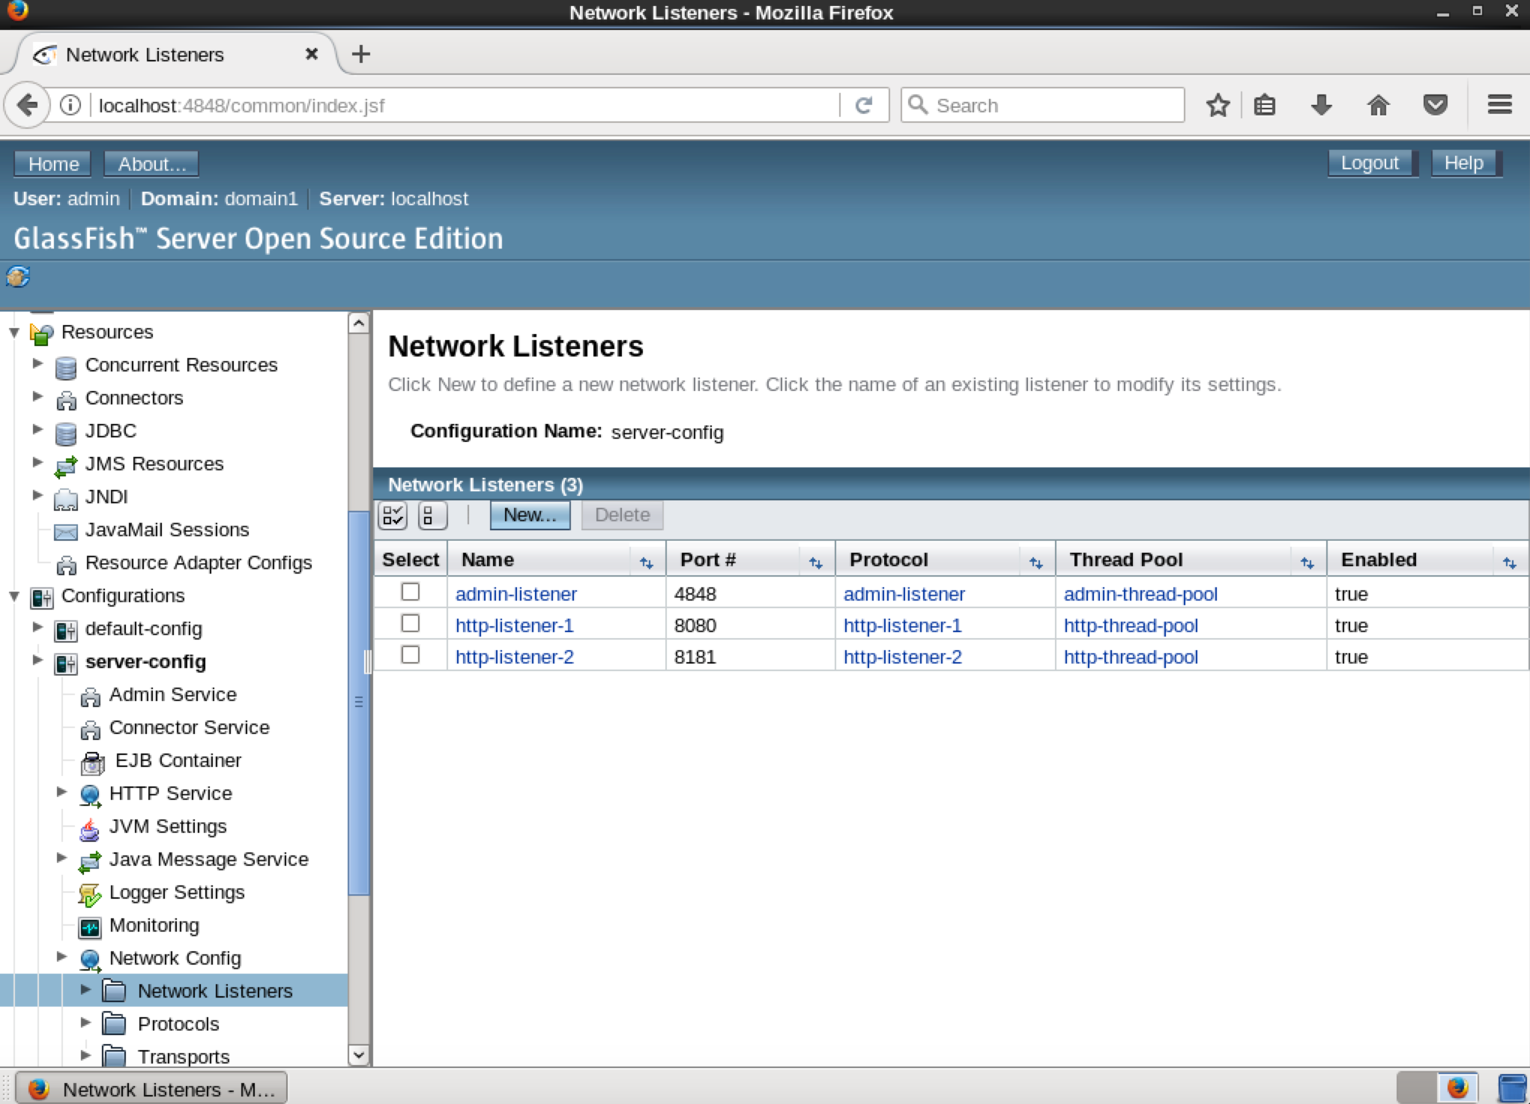

We’ll change those ports to the appropriate HTTP and HTTPS ports 80 and 443.

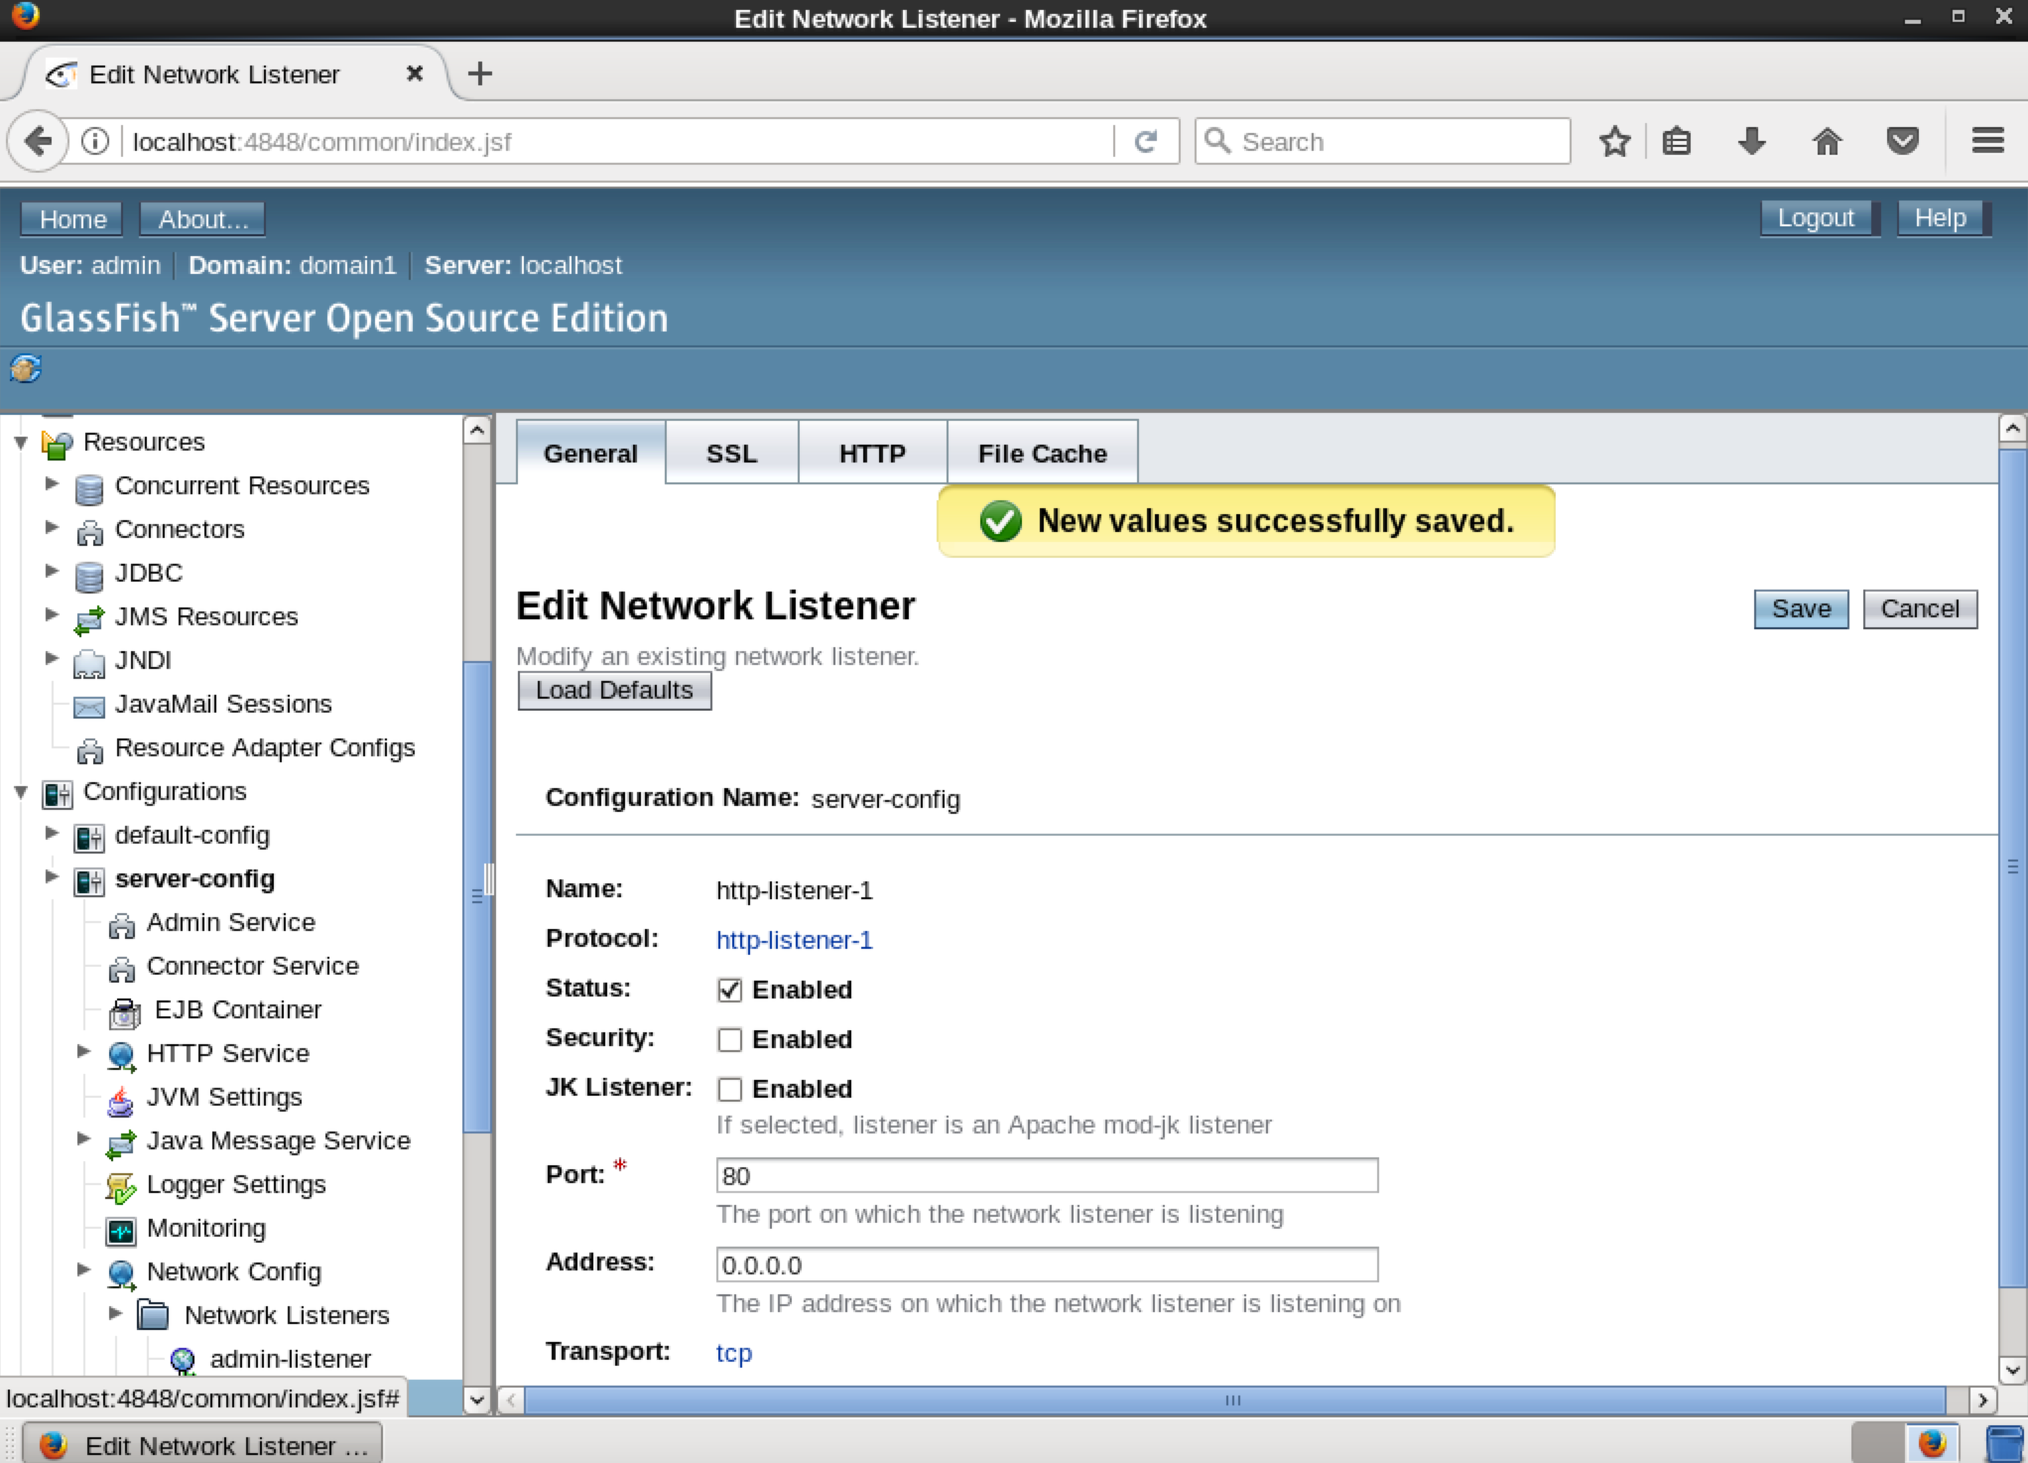

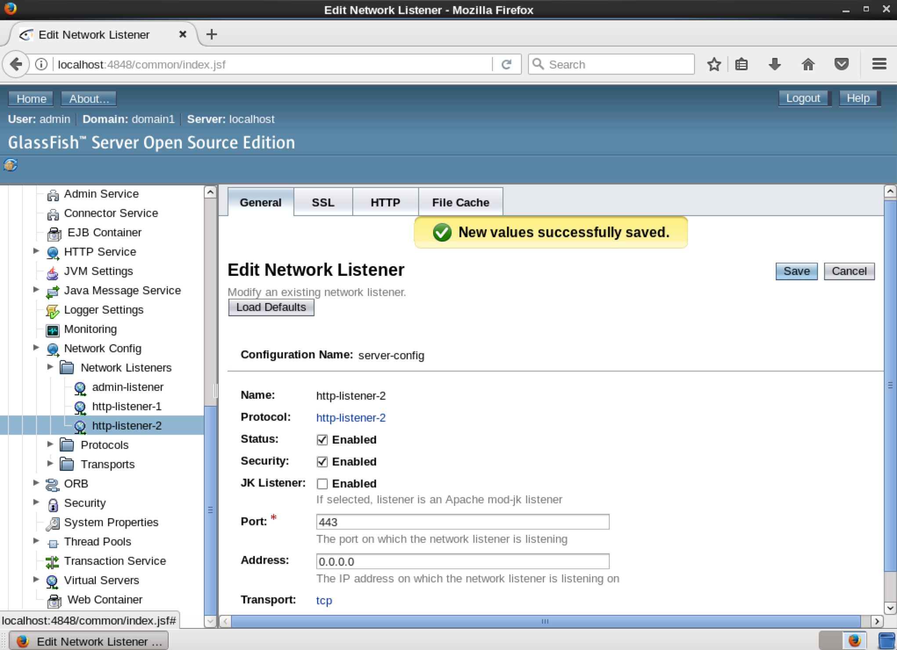

Your ‘*Network Listeners*’ screen should look like this after your changes.

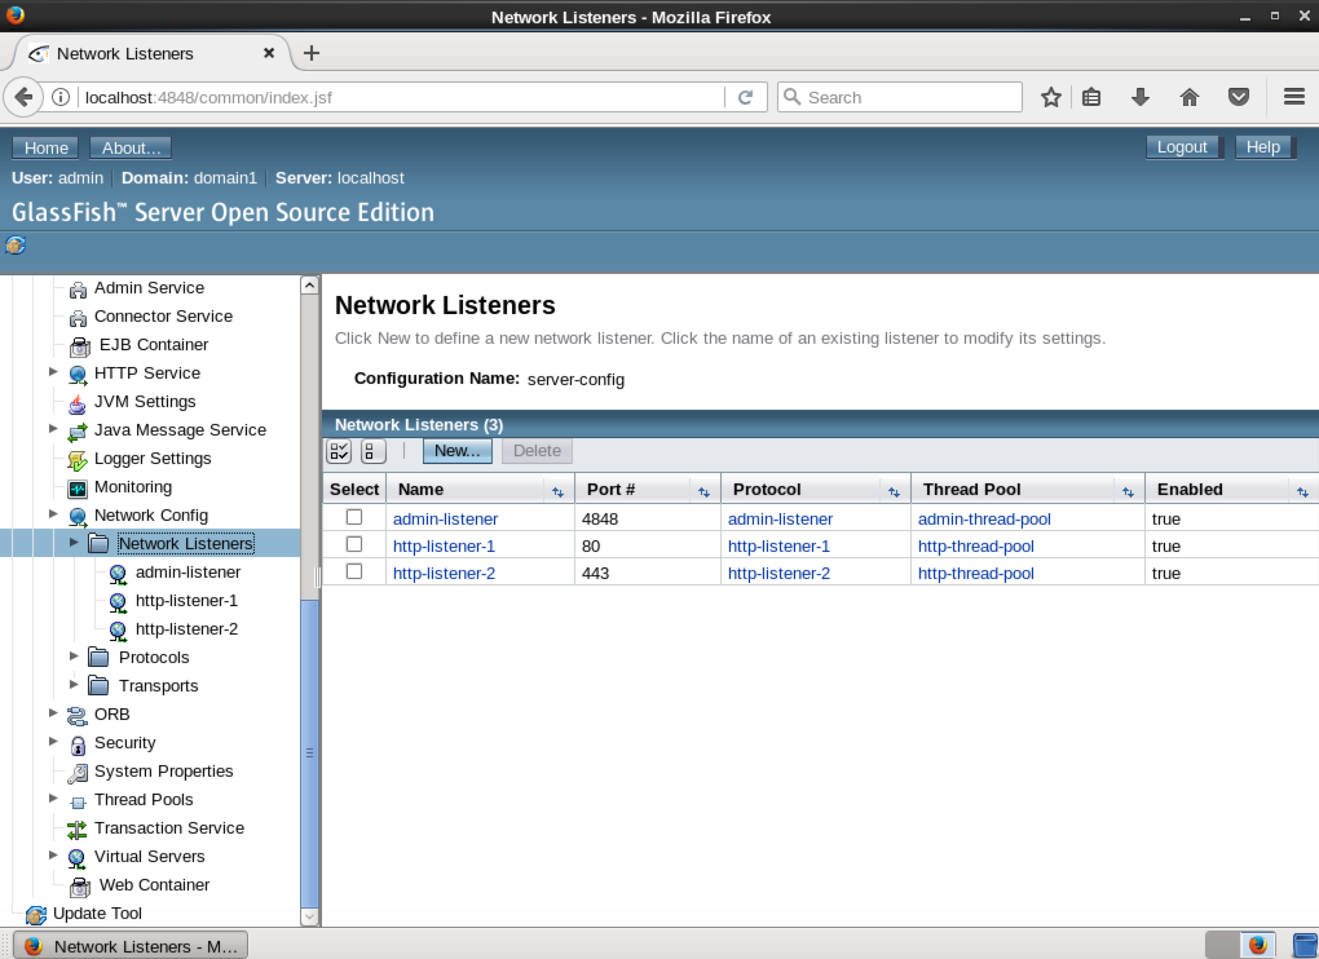

Visit your cloud software application once again and omit the port 8080 number this time!

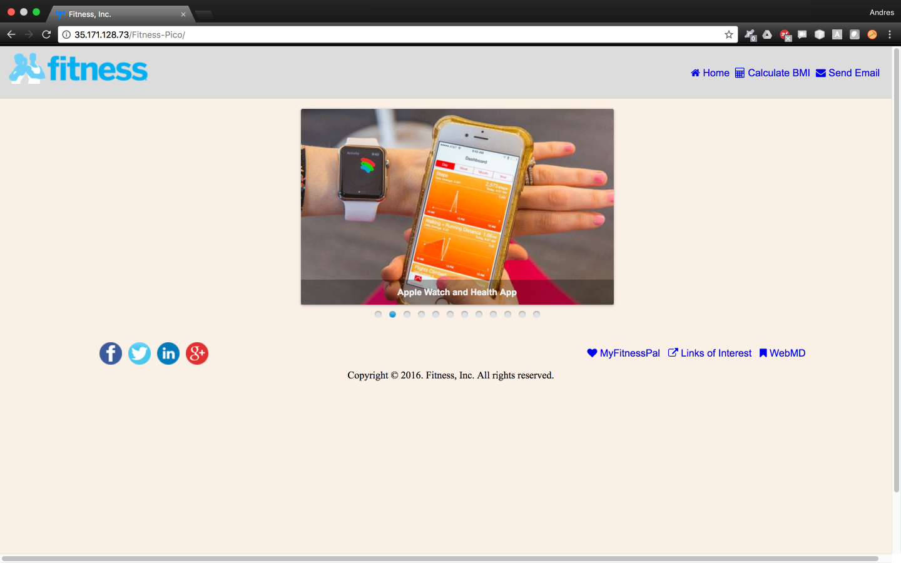

If you used a domain name for your software solution then your url should look like this.

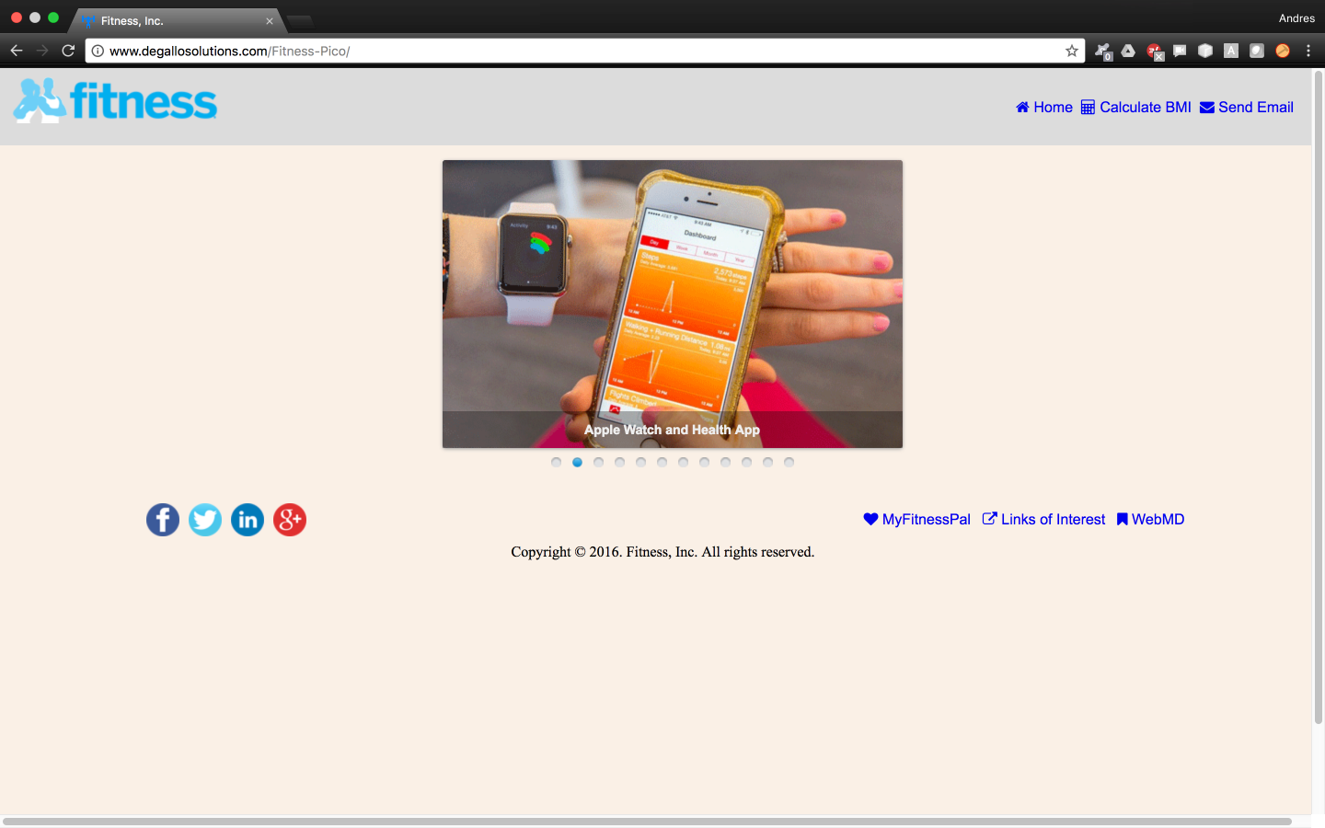

# 

# REFERENCES

Amazon Web Services (2018), “Launch a Linux Virtual Machine,” Amazon, Seattle, WA, <https://aws.amazon.com/getting-started/tutorials/launch-a-virtual-machine/>

Amazon Web Services (2018), “Register a Domain Name,” Amazon, Seattle, WA, <https://aws.amazon.com/getting-started/tutorials/get-a-domain/>

Amazon Web Services (2018), “AWS Marketplace - CentOS,” Amazon, Seattle, WA, <https://aws.amazon.com/marketplace/seller-profile?id=16cb8b03-256e-4dde-8f34-1b0f377efe89>

Amazon Web Services (2018), “AWS Marketplace – CentOS 6 (x86_64),” Amazon, Seattle, WA, <https://aws.amazon.com/marketplace/pp/B00A6KUVBW?qid=1520463970756&sr=0-4&ref_=srh_res_product_title>

Linux and Ubuntu (2016), “10 Things To Do After Installing CentOS,” Linux and Ubuntu, <http://www.linuxandubuntu.com/home/10-things-to-do-after-installing-centos>

CentOS (2015), “Install nano on CentOS,” Red Hat Enterprise Linux, Raleigh, NC, <https://www.centos.org/forums/viewtopic.php?t=52506>

SkyTech (2012), “How to Install Unzip to Extract Zip File on Linux RHEL, CentOS, Oracle Linux 6/7,” ehowstuffworks, Atlanta, GA, <https://www.ehowstuff.com/how-to-install-unzip-to-extract-zip-file-on-linux-rhel-centos-oracle-linux-67/>

Anicas, M (2016), “How to Create a Sudo User on CentOS,” DigitalOcean, New York City, NY, <https://www.digitalocean.com/community/tutorials/how-to-create-a-sudo-user-on-centos-quickstart>

Linux Community (2012), “Adding User to Sudo List on CentOS,” LinuxQuestions, <https://www.linuxquestions.org/questions/linux-newbie-8/adding-user-to-sudo-list-on-centos-4175591582/>

Park, B (2017), “How to Add a User to Sudoers in CentOS Linux,” WebHostingHero, <https://www.webhostinghero.com/add-a-user-to-sudoers-in-centos-linux/>

Kishore, S (2015), “VNC Server Installation on CentOS 6.5,” HowToForge, <https://www.howtoforge.com/vnc-server-installation-centos-6.5>

Rbgeek (2012), “How to Install VNC Server on CentOS 6,” Lazy Geek, <https://rbgeek.wordpress.com/2012/06/26/how-to-install-vnc-server-on-centos-6/>

Julfi Tutorials (2014), “How to Install Graphical Desktop in EC2 Instance Ubuntu 14.04 (Linux) and Access from Windows PC,” Youtube, San Bruno, CA, <https://www.youtube.com/watch?v=ljvgwmJCUjw>

BOINCisHOT (2011), “How to Create an Ubuntu Linux Graphical Desktop in the Amazon EC2 Cloud and View it Using Windows,” Youtube, San Bruno, CA, <https://www.youtube.com/watch?v=WeIw4CjwQ44>

RealVNC (2018), “Download VNC Viewer to the Device to Control from,” RealVNC, Cambridge, UK, <https://www.realvnc.com/en/connect/download/viewer/>

LynuxAdim (2015), “How to Install GlassFish on a CentOS 6 VPS,” Linux System Admin, <https://lynuxadmin.blogspot.com/2015/05/how-to-install-glassfish-on-centos-6-vps.html>

Nizam, H (2013), “Installing GlassFish Server Open Source Edition 4.0 on a CentOS 6.4,” Hazrul Nizam’s Journal, <https://blog.hazrulnizam.com/installing-glassfish-server-open-source-edition-4-0-on-centos-6-4/>

CentOS (2014), “IPTables,” Red Hat Enterprise Linux, Raleigh, NC, <https://www.centos.org/forums/viewtopic.php?t=52506>

Saldarriaga, J (2015), “Copying Files Between Local Computer and Instance (AWS),” Columbia University, New York City, NY, <https://github.com/juanfrans/notes/wiki/Copying-Files-Between-Local-Computer-and-Instance-(AWS)>

Lawruk, J (2014), “Why Can’t I Reach my Amazon EC2 Instance Via its Elastic IP Address,” ServerFault, <https://serverfault.com/questions/356598/why-cant-i-reach-my-amazon-ec2-instance-via-its-elastic-ip-address>

Rampal, A (2015), “Firewall Config for Java Web App Hosted on AWS EC2 Windows 2012 Server,” Abhi Rampal Archives, <https://abhirampal.com/2015/08/04/firewall-config-for-java-web-app-hosted-on-aws-ec2-windows-2012-server/>

GoDaddy (2018), “Change my IP Address,” GoDaddy, Scottsdale, AZ, <https://uk.godaddy.com/help/change-my-ip-address-20134>

Handy, M (2011), “How to Change Default Start Page of GlassFish,” StackOverflow, New York City, NY, <https://stackoverflow.com/questions/6287577/how-to-change-default-start-page-of-glassfish>

Jjd (2012), “How to set Domain Name for Web Application in GlassFish,” StackOverflow, New York City, NY, <https://stackoverflow.com/questions/11966756/how-to-set-domain-name-for-web-application-in-glassfish>

Hafner, S (2013), “GlassFish and Https Running Secure Applications,” The Java Dude Weblog, <https://javadude.wordpress.com/2013/03/25/glassfish-and-https-running-secure-applications/>

Hafner, S (2013), “GlassFish V3.1.2 and SSL,” The Java Dude Weblog, <https://javadude.wordpress.com/2013/03/22/glassfish-v3-1-2-and-ssl/>

Heeschen, J (2016), “Install a MySQL Server on CentOS,” Rackspace, Windcrest, TX, <https://support.rackspace.com/how-to/installing-mysql-server-on-centos/>

Sverdlov, E (2012), “A Basic MySQL Tutorial,” DigitalOcean, New York City, NY, <https://www.digitalocean.com/community/tutorials/a-basic-mysql-tutorial>

Edwards, T (2012), “How to Run an SQL Text File on a MySQL Database,” StackOverflow, New York City, NY, <https://stackoverflow.com/questions/8940230/how-can-i-run-an-sql-text-file-on-a-mysql-database>

Filip (2017), “How to Configure GlassFish 4 with MySQL,” Java Tutorial Network, <https://javatutorial.net/configure-glassfish-mysql>

Mike (2015), “GlassFish Http Status 500 – Internal Server Error,” StackOverflow, New York City, NY, <https://stackoverflow.com/questions/28151234/glassfish-http-status-500-internal-server-error>